Gisselle & Scott’s Handout

Encryption basically works like this: Let M, C, K, define sets. M will be your the message space. C is the cyphertext space. Cyphertext is what you call a message that has been encrypted. K is the keyspace. Every e∈K is called a key and defines a unique bijection, denoted E_{e}, also called the encryption function, from M to C. In this manner, we know that every message m ∈M maps to a unique cyphertext c∈C and that every cyphertext will map to a unique message as well. Each d∈K defines a function, D_{d}, which is the counterpart to E_{e}, called the decryption function. The decryption function defines a bijection from C to M. An encryption shcheme will thus consist of a unique ecryption and decryption function, such that D_{d} = E_{e}⁻¹ , that is D_{d} ( E_{e} ) = m. In this case the key or key pair is (e,d) .
Encryption techniques are divided into two main branches: symmetric key encryption and public key encryption. In symmetric key encryption it is computationally ‘easy’ to compute d from e and vice versa. A classic example of a symmetric key encryption scheme is the the Shift cypher:
Suppose you want to encrypt the text FROG using the Shift cypher with e = 4. Each letter will be shifted forward 4 places in the alphabet.
f → j
t → v
o →s
g →k
Your top seret encrypted information is now JVSK. To decrypt, simply perform the reverse operation, (shift the letters back 4 spaces).
In public key encryption it is computationally infeasible to compute d from e (in other encryption schemes this is not the case). The following is the scenario for a public key encryption scheme. So, say A and B wish to communicate. A computes (e,d). A sends e to B. Anyone who wants to can see e. However, since it is impossible to compute d knowing only e, it doesn’t matter that anyone can have access to e. Later, B encrypts his message with e and sends it to A. A will then decrypt the message with d. RSA, which we will be focusing on, is a particular example of a public key encryption scheme.

There are some basic concepts and theorems that are required in order to understand how RSA encryption works:

The equivalence class of a, denoted [a] consists of all b’s | (bRa).

The equivalence class mod n of an integer [a] is the set of all b’s| b ≡ [a] mod n.

b ≡ a mod n means (b-a)/ n = Z, where Z is an integer (in other words n⏐(b-a). It follows that b = [a] + nZ.

If a ≡ a₁ mod n b ≡ b₁ modn. Then a + b ≡ ([a₁ + b₁]) mod n. Also, ab ≡ a₁b₁ mod n.
For example, [1] mod 4 + [2] mod 4 is the same as [3] mod 4

The integers mod n, denoted z_{n} , is the set of equivalence classes mod n {0,1… (n-1)}
Note that we only go up to (n-1) because once we reach n and above, the equivalence classes are equal. Thus, [0] = [n], [1] = [n+1]… This is because:

[0] = b | b ≡ [0] mod n
[n] = c | c ≡ [n] mod n
[0] = b = 0 + nZ (where Z is an integer)
[n] = c = n + nZ
c = n(1 + Z), 1 + Z is an integer, so we can call it Z₁
Thus, c = 0 + n(Z₁), which is the same as b.
It also follows that any equivalence class multiple of n, [Z•n] = [0]

The multilicative inverse of a mod n is an integer [x] ∈ Z_{n} | [a][x] ≡ 1 mod n
For example, the multiplicative inverse of [5] mod 9 is [2] , because
5 • 2 ≡ 1 mod 9 ( (10-1)/9 = Z, where Z is the integer 1)

It is a fact that a mod n has an inverse if and only if GCD(a,n) = 1. (Remember that GCD(a,n) = 1 implies that a and n are relatively prime).

Proof:

Suppose 0<k<n and GCD(k,n) ≠ 1.
Show that [k] mod n does not have an inverse.
We will use proof by contradiction here:

Assume, to the contrary that there is an inverse. Let the inverse equal [m].

⇒ [m][k] ≡ 1 mod n, which is shorthand for [m] mod n • [k] mod n ≡ 1 mod n

Let d = GCD (k,n) d>1

Multiply both sides by [n/d], you get:
[n• (k/d)] mod n • [m] mod n ≡ [n/d] mod n

Since d divides k, n • (k/d) is a multiple of n, so [n• (k/d)] mod n = [0] mod n (Proved already)

So, we substitute [0] mod n for [n• (k/d)] mod n. We know (because we can do multiplication mod d) that:
[0] mod n • [m] mod n = [0] mod n

So, we get [0] mod n ≡ (n/d) mod n. This is wrong because ( 0- (n/d)) / n = 1/d, and 1/d is not an integer, so we can’t establish congruency. Thus, our assumption must be incorrect. Consequently, [k] mod n only has an inverse if GCD(k,n) = 1, which is what we wanted to prove.

The Euler function φ(n), denotes, for n 1, the number of integers in the interval [1,n] which are relatively prime to n.

If p is prime φ(p) = (p-1), (since all integers from 1 to n-1 are relatively prime to p.

Also, the Euler function is multiplicative. Thus, if GCD(m,n) = 1, then φ(mn) =
φ(n) • φ(m). So, for example, φ(22) = φ(11) • φ(2) = (11-1) (2-1) = 10. Thus there are 10 integers that are relatively prime to 22.

(The following theorems are stated without proof)

Fermat’s theorem (which is a special case of Euler’s theorem, which is not mentioned here) says that:
If GCD(a,p) = 1, then a^{(p-1)} ≡ 1 mod p
Also if, r ≡ s mod (p-1) , then a^{r} ≡ a^{s} mod p
And, in particular, a^{p} ≡ a mod p, for all integers a

The Chinese Remainder theorem states that if the integers n₁, n₂, … n_{k} are pairwise relatively prime, the system of simultaneous congruences

x ≡ a₁ mod n₁
x ≡ a₂ mod n₂…
x ≡ a_{n} mod n_{n}

has a unique solution mod n = n₁ • n₂ • n_{n}

RSA
KEY GENERATION : A does the following
- First we generate two large random and distinct primes p and q, each about the same size

- We compute n = pq, and φ(n), or φ(pq) = (p-1)(q-1) (Remember p and q are primes, and the Euler function is multiplicative so φ(pq) = φ(p) • φ(q) )

- We select a random integer e, such that 1<e<φ(n), such that GCD(e, φ(n)) = 1

- We compute ed ≡ 1 mod φ(n) (The reason why we chose GCD(e, φ(n)) = 1, was so that e could have an inverse. (Remember the proof). Here, d is the multiplicative inverse of e mod φ(n))

- A’s public key is (n,e): A’s private key is d.

ENCRYPTION: B encrypts a message for A and A decrypts it.

B does:
1. Obtain the key (n.e)

2. Represent the message as an integer in the interval [0, n-1]

3. Compute c = m^{e} mod n

4. Send the cyphertext to A

A does:
- Use the private key d, to recover m = c^{d} mod n

Proof that decryption works:

Since ed ≡ 1 mod φ(n), there exists an integer k such that ed –1/φ(n) = k. In other words, ed = 1 + kφ(n), or ed = 1 + k(p-1)(q-1). (Remember n = pq, where p and q are primes)

Now, if GCD(m,p) = 1, then by Fermat’s theorem: m^{(p-1)} ≡ 1 mod p

Raising both sides to the power k(q-1) and then multiplying both sides by m yields:
m•m^{(p-1)(q-1)k} ≡ m mod p
m^{1+(p-1)(q-1)k} ≡ m mod p (which is the same as:)
m^{1+kφ(n)} ≡ m mod p
m^{ed} ≡ m mod p

We can also make the same argument if we had started with: m^{(q-1)} ≡ 1 mod p
and say, m^{ed} ≡ m mod q

Thus, since p and q are distinct primes, by the chinese remainder theorem it follows that:

m^{ed} ≡ m mod n,

and, hence, c^{d} ≡ (m^{e})^{d} ≡ m mod n

Although knowing e and n is not sufficient for an attacker to break the encryption, if the attacker can determine the primes p and q used to generate n, he can use these to compute φ(n) and use this to find the private key d. Thus, the difficulty of breaking RSA is equivalent to the difficulty of factoring n.

The best currently-known algorithms for factoring an arbitrary integer are extremely inefficient and cease to work well once the integer to be factored exceeds about 160 decimal digits. If a sufficiently large n is used for the RSA modulus, then there is little chance that the encryption will be broken within the lifetime of the universe.

Walter & Jaime’s handout
There are basically two types of encryption currently: private key (symmetric) and public key (asymmetric.)
With private key encryption, a “key” piece of information is used both to encode and decode messages. This key must be kept secret, as well as the method by which it is applied for optimal security. Examples include: Navajo code talkers, substitution cipher method: the German Enigma machine, stick encryption, and CSS. Private key encryption is far from perfect, however. Problems include the facts that it can be inconvenient; linguists can “easily” break the encryption in many cases; the key and method need to be hidden or else the code is useless; having access to both the coded data and the corresponding unencrypted information allows the key to be discovered and the code broken. Famous examples of such encryption defeat include the Enigma and CSS; both were broken when the method was known and both encoded and plaintext versions of the same data were obtained.
Public key encryption is currently the most used form of encryption. With this, data is encrypted with one key and decrypted with another; the first is the public key and the second is the private key, which is why this is called asymmetric encryption.
Interestingly, the U.S. government placed a ban on export of what it considered to be “strong” encryption at one point, despite the fact that such technology had already been discovered and put into wide use abroad. It caused, though, American companies to produce two forms of its products, such as web browsers. Ones utilizing 56-bit encryption were suitable for export, while 128-bit encryption was for use at home. The first allowed for only 2⁵⁶ possible keys, making such programs extremely easy to crack through brute force. The 128-bit security, offering 4 trillion more possible keys, was not.
RSA encryption is so secure and popular because it uses basically an infinite number of private keys that are really impossible to calculate from the public keys even though the method is known. These are the most important features of any public key encryption method. RSA is quickly becoming a de facto standard because of its merit.
Secure data backup and storage can be very desirable. However, it can be dangerous in that data can become irretrievable if the password is forgotten or the file containing the private key is somehow lost or destroyed. Email, another prime candidate for encryption, often isn’t because of its own set of problems. First, different products or servers usually use different methods of encryption. Second, using 3rd party encryption can be less secure, inconvenient, and costly. An example of the problems represented by improper implementation of encryption is found with online retailers. With these, the user can verify that data between himself and the vendor is secure; however, with some smaller merchants, it is not known whether data between themselves and their e-business provider is secure. This sort of thing is normally not a problem since reputable vendors usually do all that is necessary to secure the data. Additionally, the Secure Electronic Transaction specification sets a guideline to help with such matters.
Adam & John’s handout

Going to Las Vegas...
CRAPS--------
First roll: "shooter" rolls two die Come-Out Roll
the sum of a 7 or an 11, called a natural, means bettor automatically wins
the sum of 2, 3, or 12, called a crap, means bettor loses.
if the sum of dice is anything else 4, 5, 6, 8, 9, 10, then the player rolls
again until
he/she rolls either the point(original roll) before he/she rolls a 7.
Odds of Craps:
We assume the dice are fair, and the outcome of every roll is independant
Make N the number of rolls in game
(Xi, Yi) is the outcome of the i'th roll - i = 1, 2, 3, ..., N
Zi = Xi + Yi (sum of scores on i'th roll)
I - indicator variable that the shooter wins
First Roll(Z1):
z 2 3 4 5 6 7 8 9 10
11 12
P(Z1 = z) | 1/36 | 2/36 | 3/36 | 4/36 | 5/36 | 6/36 | 5/36 | 4/36 | 3/36 |
2/36 | 1/36
Probability Shooter will lose after first roll : 1/36+2/36+1/36=4/36 or 1/9
Probability Shooter will win after first roll : 6/36+2/36=8/36 or 2/9
Probability Shooter will roll point first roll :
3/36+4/36+5/36+5/36+4/36+3/36=24/36 or 2/3
Pretend the first roll is a 4(4 is point) either a (1, 3);(3,1); or (2, 2)
-symmetric!!
player has to roll another 4 or a 7 to end the game
so the player's final roll has to be one of these combinations
(1, 3); (2, 2); (3, 1); (1, 6); (2, 5); (3, 4); (4, 3); (5, 2); or (6, 1)
the chance of the shooter getting another 4 is 1/3
5 is point - chance of getting another 5: 2/5
(1,4); (4, 1); (2, 3); (3, 2); (1, 6); (2, 5); (3, 4); (4, 3); (5, 2); or
(6, 1)
6 is point - chance of getting another 6: 5/11
(1, 5); (5, 1); (3, 3); (2, 4); (4, 2); (1, 6); (2, 5); (3, 4); (4, 3); (5,
2); or (6, 1)
8 is point - chance of getting another 8: 5/11
(2, 6); (6, 2); (3, 5); (5, 3); (4, 4); (1, 6); (2, 5); (3, 4); (4, 3); (5,
2); or (6, 1)
9 is point - chance of getting another 9: 2/5
(3, 6); (6, 3); (4, 5); (5, 4); (1, 6); (2, 5); (3, 4); (4, 3); (5, 2); or
(6, 1)
10 is point - chance of getting another 10: 1/3
(4, 6); (6, 4); (5, 5); (1, 6); (2, 5); (3, 4); (4, 3); (5, 2); or (6, 1)
Chances of Winning in Craps -
6/36+2/36+(3/36)(1/3)+(4/36)(2/5)+(5/36)(5/11)+(3/36)(1/3)+(4/36)(2/5)+(5/36)(5/11)
these odds are 244/495 which is approximately 49.2929% of the time winning
this is found by adding the chances of getting a 7 or 11 the first roll,
then the chances
of getting 4, 5, 6, 8, 9, or 10 then multiply each one of those chances by
the probability of rolling that point again before a 7.
Chances of Losing in Craps -
1 - (244/495) = 251/495 which is approximately 50.70% loss in craps
Craps is one of the only games that has almost even odds.
If you place n bets for $P then the average gain is:
nP(244 / 495 - 251 / 495) = -7nP / 495
average gain in games of chance can be found by subtracting the chance of
losing from the chance
of winning, then multiply that number by the amount of money and number of
bets the
person wishes to make.
FLORIDA LOTTERY--------
the number of balls is 53, and a person buys a ticket and chooses 6
different numbers
there is no repetition in the 6 ball Florida Lottery
order does not matter in choosing balls
53*52*51*50*49*48= 16,529,385,600 / (1 * 2 * 3 * 4 * 5 * 6) = 1 out of
22,957,480
or simply (53 C 6) is the chance of getting all 6 numbers right
To find out if you got 5/6 numbers right:
there are 6*47=282 ways to get 5/6 numbers right
22,957,480/276 = 1 out of 81,410
To find out if you got 4/6 numbers right:
there are 15 (6 C 4) ways to include four of the six winning numbers, 1081
(47 C 2) ways to
include two of the 47 non-winning numbers, 15 x 1081 = 16,215
22,957,480/16215 = 1 out of 1,416
To find out if you got 3/6 numbers right:
there are 20 (6 C 3) ways to include three of six winning numbers, 16,215
ways to include 3
of the 47 non-winning numbers, 20 * 16215 = 324,300
22,957,480/324,300 = 1 out of 71
made comp program to simulate this, bought 10,000,000 million tickets
3 out of 6 - 141,646
4 out of 6 - 6,958
5 out of 6 - 128
6 out of 6 - 1
Odds got from this simulation
3 out of 6 - 10,000,000 / 141,646 = one out of every 70.6 tickets
4 out of 6 - 10,000,000 / 6,958 = one out of every 1,437.1 tickets
5 out of 6 - 10,000,000 / 128 = one out of every 78,125 tickets
6 out of 6 - 10,000,000 / 1 = one out of every 10,000,000 tickets

Jeff & Carlton’s Handout

Fibonacci numbers were created by Leonardo Fibonacci. Fibonacci was a 13th Century mathematician. He was born in Italy under the name Leonardo Pisano. In 1202, Fibonacci wrote the Liber Abaci, which explained how Hindu-Arabic numbers can be used in computation. This book did assist in the downfall of the roman numerals, and the creation of some algebraic and geometric principals. His number sequence is what he is known for best for, and is still being researched today.
Francois Edouard Anatole Lucas exactly one day, 159 years ago in Ameins, France. He was the son of a laborer but his mathematical talents allowed him to attend Ecole polytechnique, a polytechnic school and Ecole normale, teacher training school. When I speak of mathematical talents I mean the ability to do small things like proving 170141183460469231731687303715884105727 is prime, the largest number to be proven prime without the use of a computer. After he graduated from Ecole normale, teacher training school, in 1864, he went to work as an assistant astronomer. He worked with Urbain Leverrier, who managed to calculate the position of Neptune by observing wobbles in Uranus. He served as an artillery officer in the Franco-Prussian war. Twice he was nominated for the Legion of Honor, proving once and for all that trigonometry and parametric equations are good for something.
Fibonacci numbers, originated by the question of how many rabbits could you get from a pair in a year under the following conditions: There is one pair of rabbits inan enclosure on the first day of January; this pair will produce another pair of rabbits on Feb. 1st an on the new day of every month thereafter; and each new pair will mature for one month and then produce a new pair on the first day of the third month of its life span and on the first day of every month thereafter. This produce the sequence, "0,1,1,2,3,5,8,13,21..."To find a number in the sequence, there's the recursive method Fn=Fn-1+Fn-2, or to find a number higher up in the sequence, there's the closed form Fn=(?n-?n)/51/2.
There is also a Fibonacci quadratic equation ?=(1+51/2)/2) (?=(1-51/2)/2, and can be used to find a point on a segment where the larger portion is the mean proportional between the whole segment and lesser part. The positive root is also known as the golden section, which yields the ration 1.618.
Fibonacci numbers also have a connection with primes. Each prime number in the list will have a multiple of the number at a position n further, so F3 would have a multiple at F6. This also works with standard divisibility, where Fn is divisible by Fm if and only if n is divisible by m.
Pascal's Triangle also comes to play. As you all should know, Pascal's Triangle consists of numbers starting at one and the next row is the sum of the two numbers it would be next to in the previous row. If the triangle is left justified, you can draw diagonal lines starting from the left and going to the right. The sum of the numbers will add up to a Fibonacci number.
In the same way that Einstein is far more likely to be remembered for the Theory of Relativity, and E=MC2 Lucas is far more likely to remembered for his work on primality testing and the series that bears his name, than his work in a host of other subjects. He wrote papers on astronomy, geometry, analysis, beloved combinatorics, calculating devices and and of course, weaving.
He also invented the tower of Hanoi game. He published it under the name of M. Claus, an anagram of Lucas. In the story he told a god had placed 64 golden disk the thickness of a bee on a tower, and it was the task of some priest to move the disk from one tower to the next. When their task was completed the universe would be destroyed. If that wasn't enough it has been used as a delightful example of recursion by countless computer science teachers throughout the years.
Lucas Numbers share a number of similarities with Fibonacci sequences. In fact it was Edouard Lucas who gave the Fibonacci sequence its current name. It was previously called the series of Lame. He discovered that Leonardo of Pisa, nicked Fibonacci, short for Filio Bonocij, had known about the series centuries earlier. He also noted that if F(n) is the way in which a Fibonacci sequence is described, n being the index, and F(n) describing the term of the Fibonacci sequence for that particular value of n, that if n 1 | n 2 then F(n 1) | divides F(n 2 ). This may not seem important until you realize that F(29) =541229 and F(58)= 591286729879. They may not seem important either, until some ask you if 591286729879 is divisible by 541229, and you don't have a calculator. While it may not be likely that your life will ever depend on such information, it is nice to know that the information exist just the same.
The Lucas and Fibonacci sequences have a large number of similarities. First of all both sequences can be defined recursively, by adding the result of the previous two terms to find the result of the next term. Second, in a Fibonacci or Lucas series the ratio of the term to the term proceding it aproaches1.6180339 as the index approaches infinity. This holds true for all series in which the next term in the series is the product of the previous two terms of the series. However peace of information that may have seemed initially useless can prove its worth and save much tedious calculation. The number 1.6180339, (5(1/2) + 1)/2, which for the sake of space will be referred to hereafter as Phi, and its multiplicative inverse, phi, can be used to calculate a Fibonacci number. What makes the process far different from the recursive way of calculating the Fibonacci number is that the number of calculations stays the same regardless of the index of the Fibonacci number. F(n) = (Phin - (-phi)n)/5.(1/2). I should note that even in realms of mathematics, or mathematical history as the case may be, there is room to disagree. While some sources attribute the aforementioned formula to Lucas, there are other sources who attribute the formula to Jacques Philippe Marie Binet
Lucas series: 1, 3, 4, 7, 11, 18, 29, 47, 76, 123, 199, 322, 521, 833, 1364, 2207, 3571 Fibonacci series: 0, 1, 1, 2, 3, 5, 8, 13, 21, 34, 55, 89, 144, 233, 377, 610, 987, 1597. It should also be noted that with more than 150 years for mathematicians to observer various properties of the Lucas numbers a number of interesting, or apathetic depending on your point of view, relation ships have been found between Lucas numbers themselves, and also between Lucas and Fibonacci numbers. For instance, the a the nth term in the Fibonacci sequence is multiplied by the nth term of the Lucas series, the result is equal to the 2nth term of the Fibonacci series. Now that you all are riveted to your seats consider this fact; the square of the nth+1 term of a Lucas number plus the square of the nth term, is equal to five times the 2nth+1 term of the Fibonacci sequence. The 2nth +1 term of the lucas series is equal to the nth+1 term squared - 5 times the square of the the nth Fibonacci. I could entertain you with a number of formulas that seem similarly interesting at first glance, but I think you should have the pleasure of seeing what else is out there for yourself, or perhaps come up with a new function yourself.

Nick & Chandler’s Handout
- What is a Network?
  - Network- a directed linear graph, where G=[N;A]—N is a finite set of elements, ie. x₁, x₂, x₃…x_{n.}
  - A is a set of elements of the form (x₁, x₂)…(x_{n-1}, x_{n}).
  - The members of N are called nodes, vertices, junction points, or points.
  - The members of A can be called arcs, links, branches, or edges.
  - We are only dealing with networks that aren’t reflexive…if there is (x,y), x ≠ y.
  - There also exists such things called undirected networks, where the members of set A are not given a direction. Also, there are mixed networks where some members of set A are given a direction and some aren’t.
  - Chains- sequence of distinct nodes in a network, such as: x₁, ( x₁,x₂), x₂,…, ( x_{n-1},x_{n}), x_{n}. Basically this is a sequence of nodes and arcs leading from x₁ to x_{n}. Short hand—x₁, x₂…x_{n}.
  - Directed Cycle- is a chain where x₁ = x_{n}.
  - A(x) “After x”-the set A(x) = {y∈ N | (x,y) ∈ A}.
  - B(x) “ Before x”- the set B(x)= {y∈ N | (y,x) ∈A}
  - Example of A(x) and B(x)- A(s) is equal to the set {x, y}. B(s) = ∅.
- Flows in Networks
Network flow is the basically a simple concept to grasp, but, at least in our case, a harder one to explain clearly. Basically, given a network, and then selecting two nodes from that network that are to be used as the starting and ending points, network flow is a measure of the number of units of some quantity able to be transported from start to finish. That probably didn’t make too much sense, so I’m going to go on and explain mathematically—hopefully it will become clearer.
As was explained earlier, a network G = [N;A] consists of both arcs and nodes. I can assign to each arc (where each arc (x, y)∈A) a capacity—which is simply a value corresponding to the maximum amount of “something” that can arrive at y from x. This value is referred to as c(x, y) for the arc (x, y). It’s easy to think of this (in a real world example) as being the load limit on a bridge—the bridge cannot carry any more weight than this amount without collapsing in on itself.
Flow across an arc is similar in concept to the capacity of an arc. Given the network G = [N;A] and a series of arcs (x, y)∈A, a value of flow across each arc can be described as well as a capacity. The flow is described as f(x, y), with the arc connecting nodes x and y together. Keeping to the bridge analogy, whereas the capacity is the total amount of weight allowed on the bridge, the arc flow would be the amount of weight usually found on it, or the number of cars that usually pass over the bridge.
Here I’m going to talk about static flow of a network. Assume that there is a network, and I pick two nodes from this network (given earlier as the starting and ending points, here they are called the source and the sink). The flow across the network from the source (s) to the sink (t) will need to satisfy the following constraint:
$$\sum_{y∈A(x)}{f(x,y)−\sum_{y∈B(x)}{f(y,x)}=\begin{aligned}\left\{v,x=s | \right\}\left\{−v,x=t | \right\}\end{aligned}\left\{\right\}}$$
In this equation, v is the net flow into the sink. As an aside, the flow going out of the sink will be –v, while the flow leaving the source is in fact just v.
Another constraint is that the flow across an arc must always be less than or equal to the capacity across the arc. This becomes obvious when going back to my little “bridge” example: the weight of the traffic going across the bridge cannot exceed the maximum weight allowed for the bridge. The equation for the relationship between arc flow and capacity is this:
$$f(x,y)≤c(x,y)$$
Now I will explain the process for determining flow at a node. It’s not overly difficult, and basically consists of summing the arc flow exiting the node and subtracting the total arc flow entering the node. Graphically, given the network
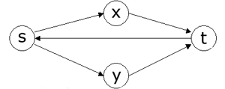
where f(s, x), f(s, y), f(x, y), f(y, t) are 3, and f(t, s) is 1, the flow from node ‘s’ is 5, and the flow at node t is –5.
- Real World Uses
  - Used to determine shipping routes
  - Used to determine which tasks are to be done by certain computers.
  - Used to determine transportation routes.

Study Guide – Eric Baumer & Judd Kussrow
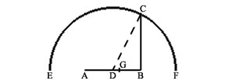

Based on the above diagram, you can calculate φ by letting |AB| = 1, |AG| = x, and |GB| = 1 – x. Substitute these values into the known equation for the golden ratio.

$\begin{aligned}\frac{\text{AB}}{\text{AG}}=\frac{\text{AG}}{\text{BG}} \\ \frac{1}{x}=\frac{x}{1−x} \\ \text{Solving for x, we have} \\ 1−x=x^{2} \\ x^{2}+x−1=0 \\ x≈\frac{−1±\sqrt{5}}{2} \\ \text{We ignore the minus, as it will give us an impossible negative distance}\text{.} \\ x≈\sqrt{1\text{.}\text{25}}−0\text{.}5 \\ x≈0\text{.}\text{618}\end{aligned}$

Using this, we can generate three solutions for φ. One, by algebraically solving the quadratic equation, in shown above. The other two are shown below.

$\begin{aligned}x^{2}=1−x \\ x=\sqrt{1−x} \\ \text{Substituting for x on the right side, we get} \\ x=\sqrt{1−\sqrt{1−x}} \\ \text{And again}\text{.}\text{.}\text{.} \\ x=\sqrt{1−\sqrt{1−\sqrt{1−\sqrt{1−x}}}} \\ x=\sqrt{1−\sqrt{1−\sqrt{1−\sqrt{1−\sqrt{1−\sqrt{1−\sqrt{1−\sqrt{1−…}}}}}}}}\end{aligned}$

Again, but slightly different and with fractions.

$\begin{aligned}x^{2}+x=1 \\ \text{Factor x for} \\ x(x+1)=1 \\ x=\frac{1}{1+x} \\ \text{Once again, we can substitute x multiple times on the right side, but} \\ \text{generating slightly different results this time}\text{.} \\ x=\frac{1}{1+\frac{1}{1+x}} \\ x=\frac{1}{1+\frac{1}{1+\frac{1}{1+\frac{1}{1+…}}}} \\ \text{Often, for simplicity, this is written as} \\ \frac{1}{1+}\frac{1}{1+}\frac{1}{1+}\frac{1}{1+}…\end{aligned}$

φ can approximate the i^{th} Fibonacci number with the formula where φ ≈ 1.61803 and ψ ≈ 0.61803.

$F_{i}=\frac{φ^{i}−ψ^{i}}{\sqrt{5}}$

To construct the golden section geometrically, and in turn create a golden rectangle, first draw BD such that it is AB / 2 and perpendicular to AB. Join AD and protract E from B by using D as the focus. Likewise find C by using E and A. C is the golden section of AB.
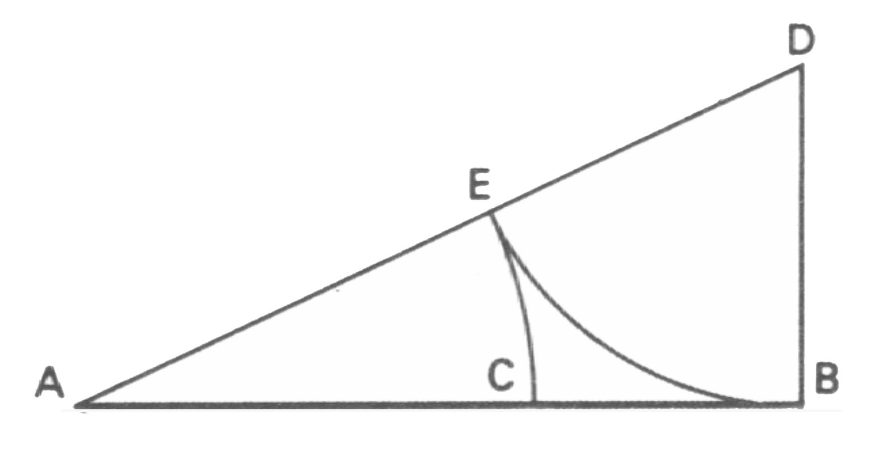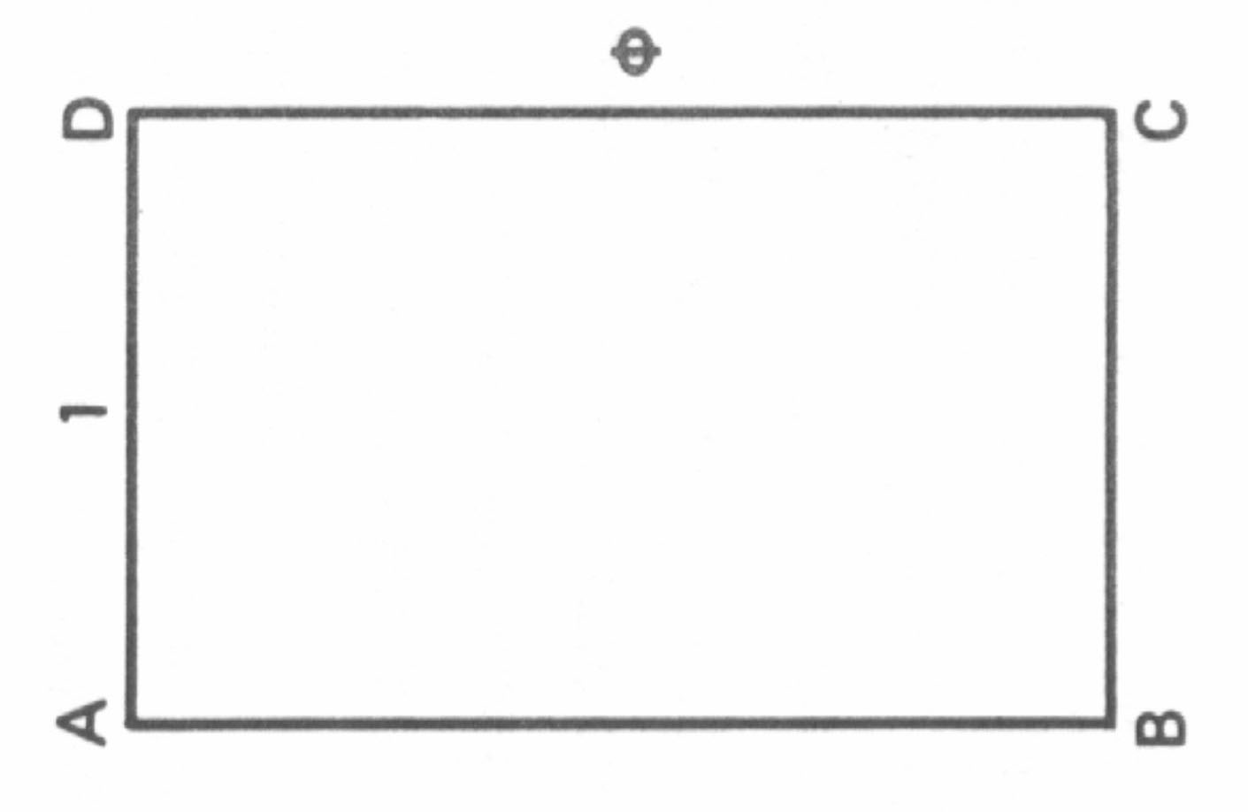
If AC is rotated ninety degrees CCW, the golden rectangle ABCD is formed. When a golden rectangle is divided according to the golden ratio, it produces another golden rectangle. This would follow according to the properties of the golden section. Furthermore, when these rectangles are produced continuously inside one another a remarkable spiral can be extracted from them. This is done by tracing a CCW logarithmic spiral through the golden section that divides outer golden rectangle into its respective sections.
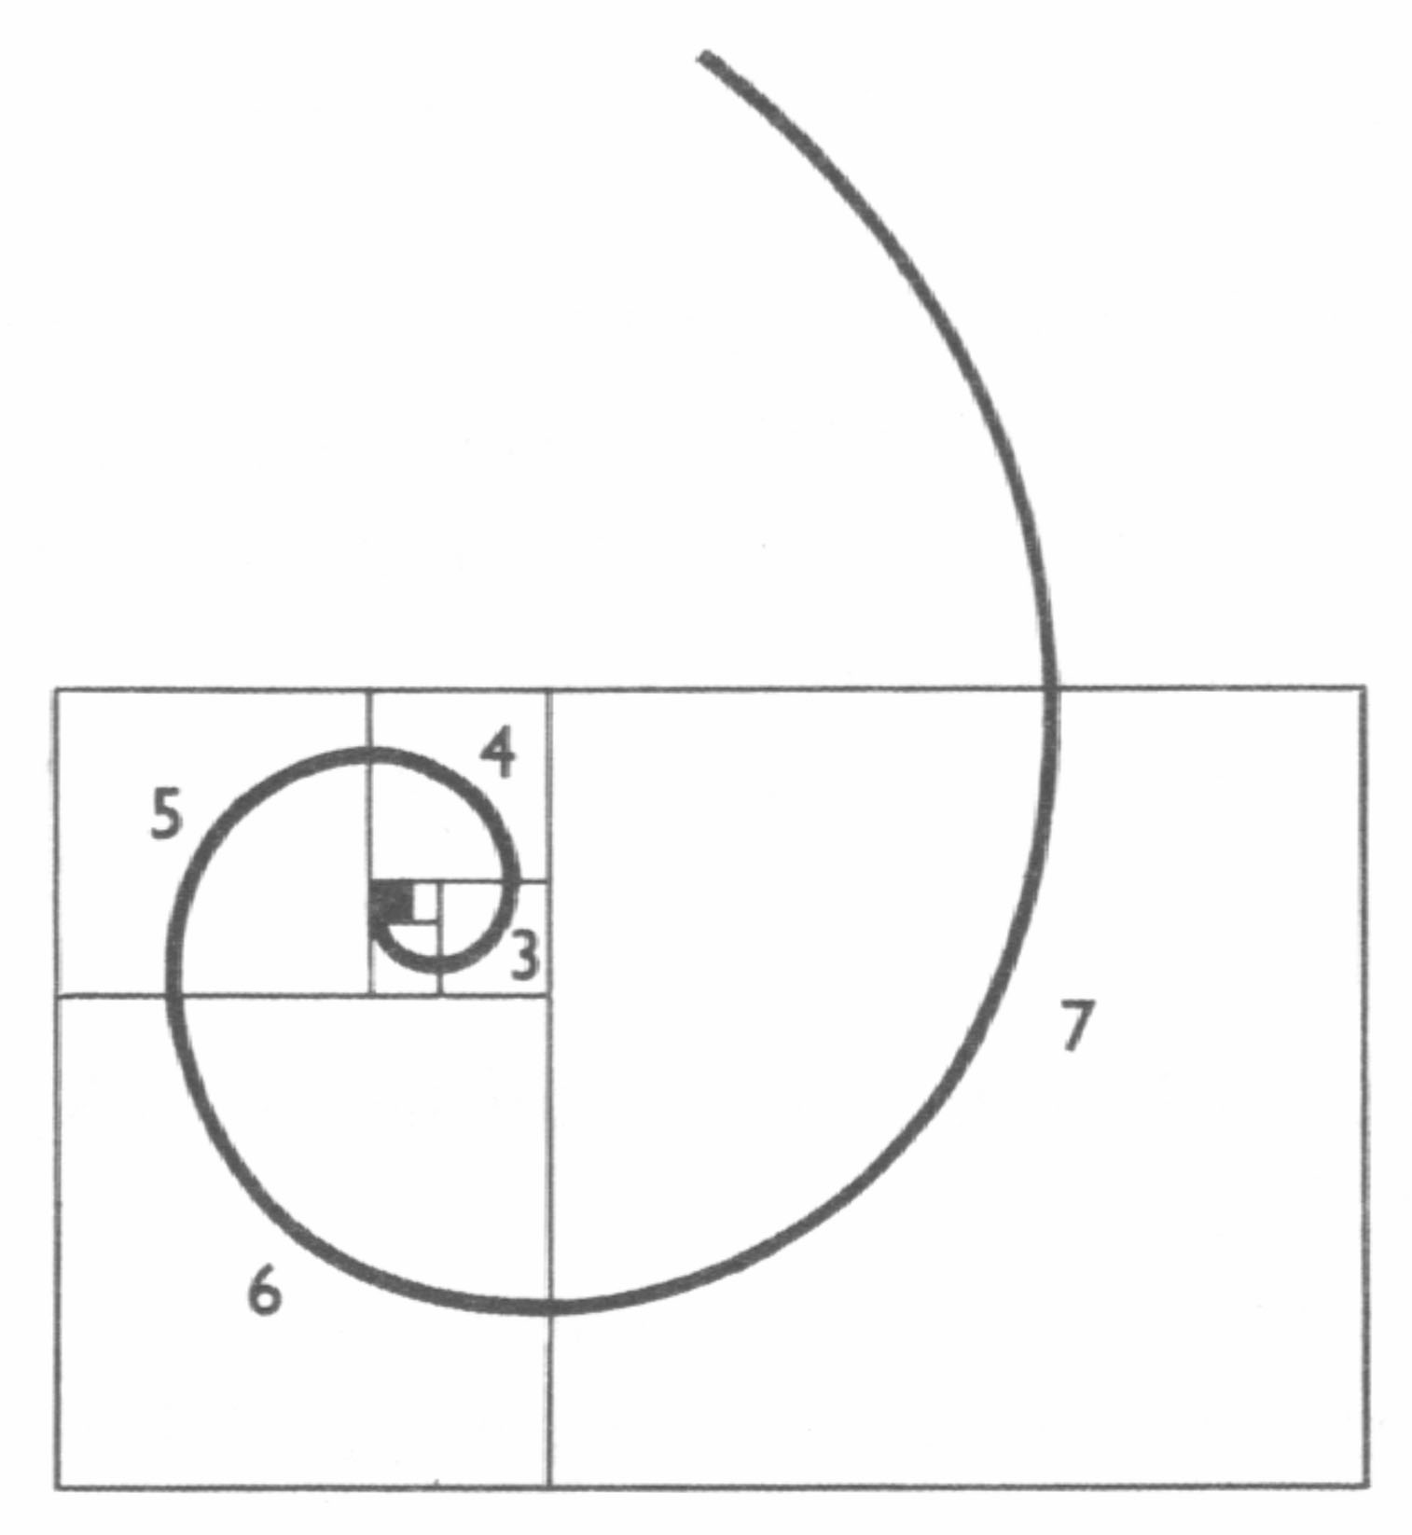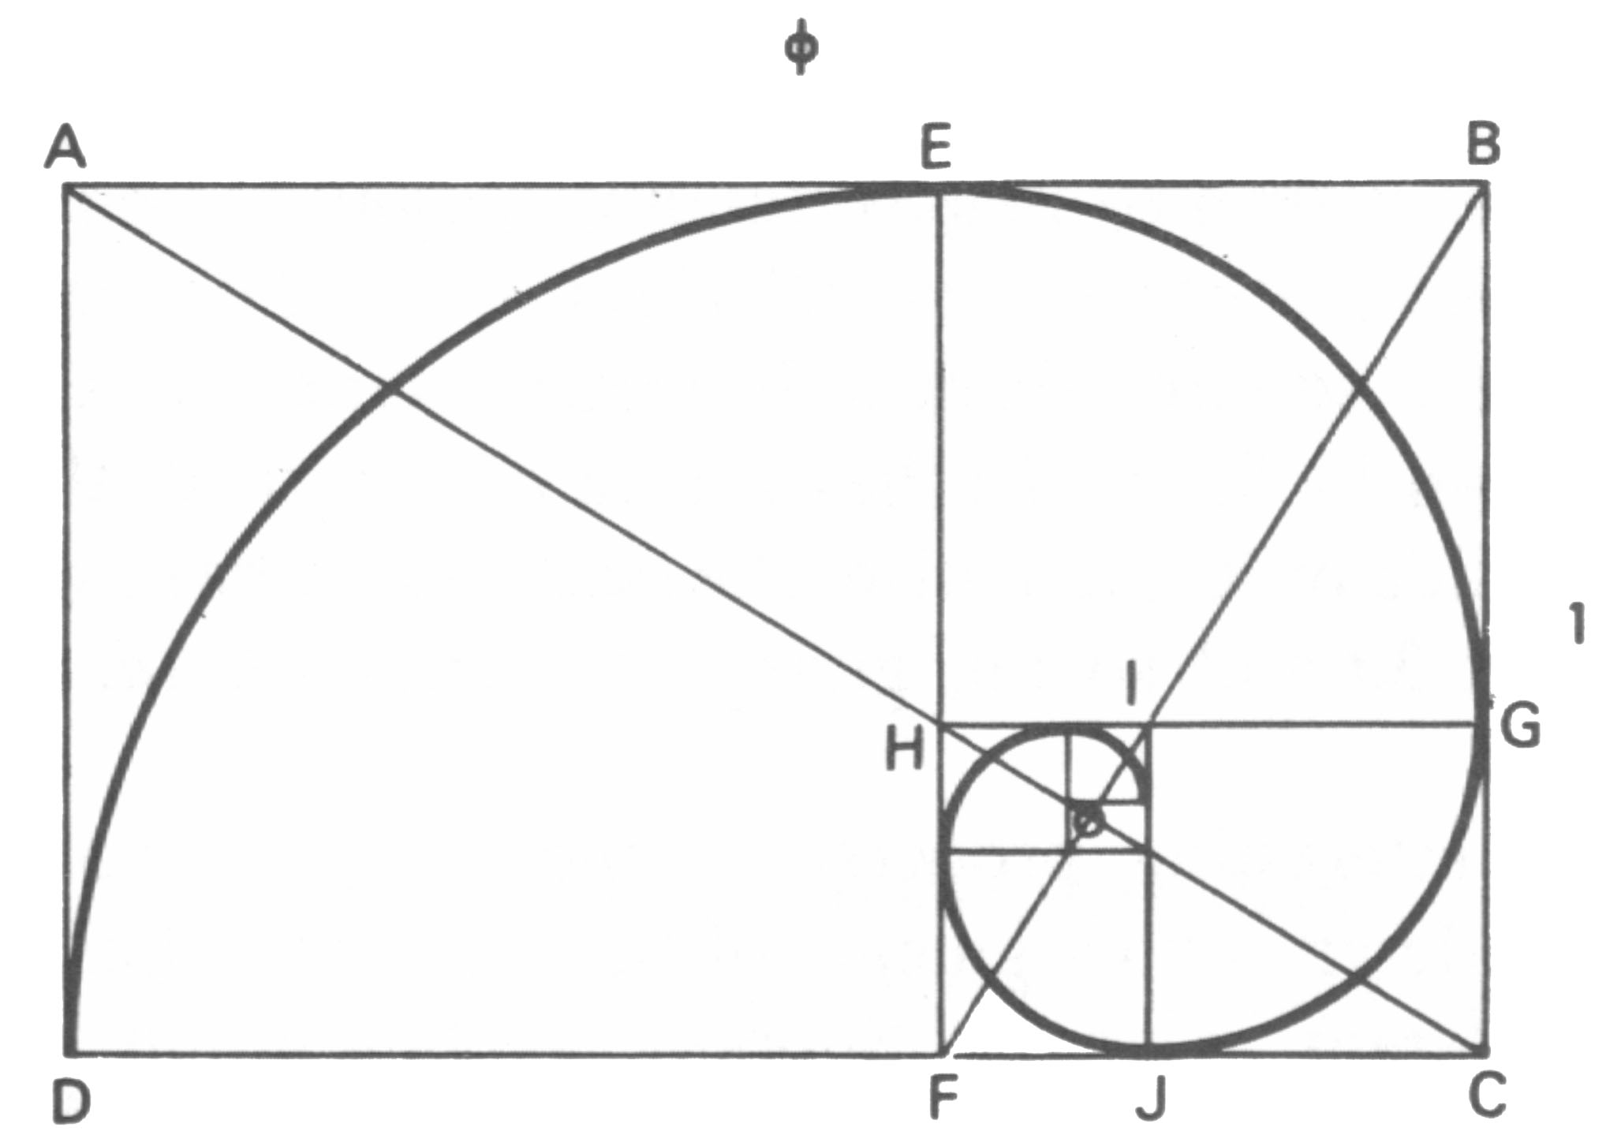

One of the most amazing demonstrations of φ can be found in a pentagram or inscribed triple triangle. In this example R, and r are the radii of the circumcircles of the pentagons A’B’C’D’E’ and PQRST respectively. PQ is taken as one unit of length.
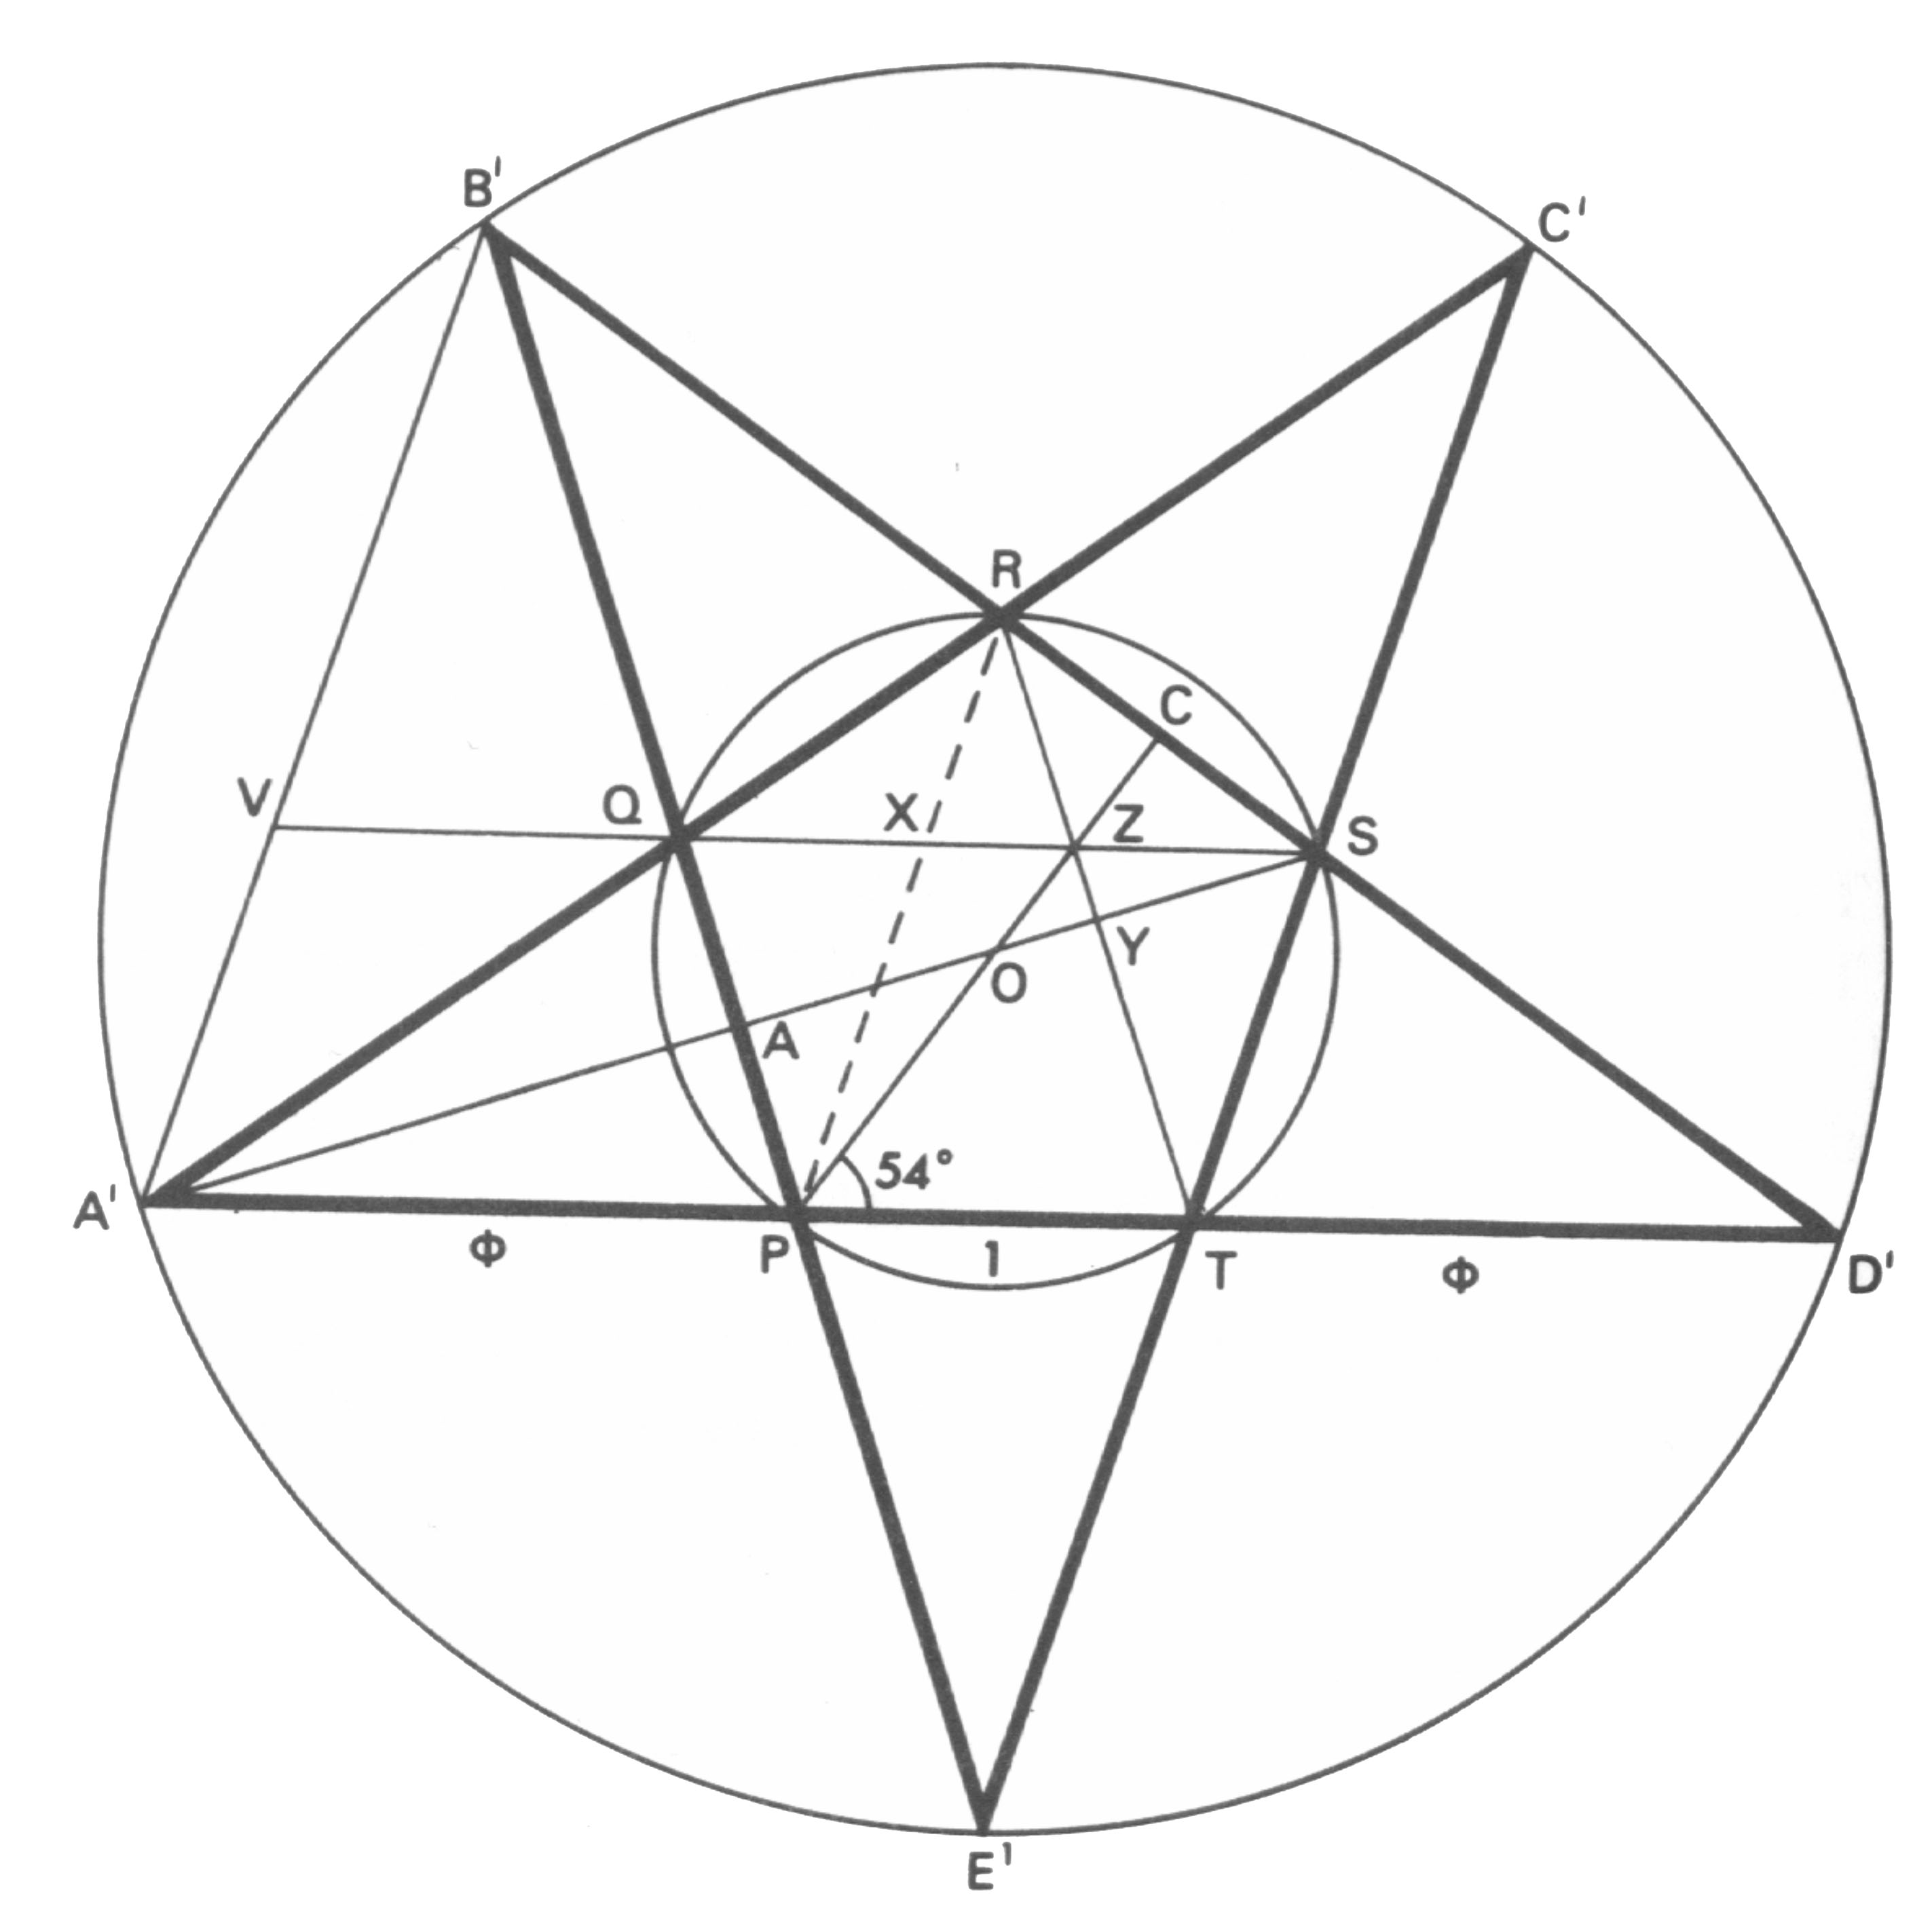
A’P = φ
OA / r = φ / 2
OA’ / r = φ²
OA’ / OA = 2φ
Any diagonal such as QS has length φ.
If X is the point of intersection of two diagonals PR, QS, then,
$\frac{\text{SX}}{\text{XQ}}=φ$ , $\frac{\text{PX}}{\text{XR}}=φ$, and $\frac{B'X}{\text{XT}}=φ$
If SQ produced meets A’B’ in V, then, since VQS is parallel to A’D’,
$$\frac{B'V}{\text{VA}'}=\frac{B'Q}{\text{QP}}=\frac{B'X}{\text{XT}}=\frac{B'S}{\text{SD}'}=φ$$
The lengths B’D’, B’S, B’R, RS, RX, & XZ are in geometric progression,
$$\begin{aligned}B'D'=φ^{3} \\ B'S=φ^{2} \\ B'R=φ \\ \text{RS}=1 \\ \text{RX}=φ^{−1} \\ \text{XZ}=φ^{−2}\end{aligned}$$
The series is also an additive series: the sum of the two numbers equals the next
$φ+φ^{2}=φ^{3}$
The length of a side of the pentagon A’B’C’D’E’ is φ² .
R / r = φ²

Shane and Craig’s Handout
Bio:
-James Stirling was born 20 km west of the Scottish town of Stirling
-The family was a strong supporter of the Jacobite cause
-Jacobite cause was that of the Stuart king, James II, exiled after the Revolution of 1688
-Stuarts were Scottish but Roman Catholic so not supported in Scotland but had exiled court in France.
-This conflict was ever present in everything Stirling did
-His father was arrested when he was 17 because of it
-In 1710 Stirling enrolled at Oxford. Other colleges like Univ. of Glasgow and Edinbrugh he was also thought to have enrolled in
-Lost many scholarships and was not able to hold certain positions because of his association with the Jacobite cause
-Had many famous teachers and associates like Taylor, Maclaurin, Simpson, and Newton, who are all famous for their work in the combinitorics field
-Most important work was Methodus Differentialis in 1730. Deals with infinite series, summation, interpolation, and quadrature. This is where Stirling numbers can be found
-Gives a sense of appreciation for what we are about to show. After all that, the man still had time for his math

Stirling Numbers of the First Kind:
Stirling Numbers of the First Kind are similar to those of the Second Kind. Denoted S1(n,r), it is the number of ways to distribute n objects into r indistinguishable cells, with no cell empty and the items arranged in a circle. This can be thought of as arranging the items around a table.
For example: take a set of 4 numbered guests and distribute the guests around two tables. In Stirling notation, that would equate to S1(4,2). Since no table can be empty, there are two possible ways to split them: one at the first table and three and the second, or two at each table.
1
2
3
1
3
4

4
2

Notice that since the tables are indistinguishable, having one at the first and three at the second is the same as having three at the first and one at the second, so those configurations are not counted.
Now notice that simple rotating the guests around the table does not result in a new configuration. All the placements below are considered the same.
2
3
4
2
3
4
2
3
4

If we were writing out the sets, {2,3,4} would be the same as {4,2,3}, which would also be the same as {3,4,2}. So, when guest 1 is alone, there are only two possible combinations of the other table: {2,3,4} and {2,4,3}. Each time you put one guest alone, you would then have two possible ways to place the other guests at the table, giving a total of 8 combinations.
With two guests at each table, there are a total of 3 combinations since switching the numbers at a table would result in the same configuration. The one way to produce a new one is to move switch guests between tables. So {1,2}{3,4}, {1,3}{2,4}, and {1,4}{2,3} are the only combination. Adding those to our previous number gives us a total of 11. So S1(4,2) is 11.
There are simpler ways to figure it out that listing and counting. One is that S1(n, r) is the coefficient of the x^r term in the expansion x(x-1)(x-2)…(x-n+1).
For instance, S1(5,2) would be the x^2 term in x(x-1)(x-2)(x-3)(x-4)
= x^5 – 10x^4 + 35x^3 - 50x^2 + 24x
So we can see that S1(5,2) is 50.
Stirling numbers can also be defined by the recurrence relation
S1(n,r) = S1(n-1,r-1) + (n-1)*S1(n-1,r)
With the base cases being these conditions
S1(n,1) = (n-1)!
S1(n,n) = 1
S1(n,n-1) = _{n}C₂

Stirling Numbers of the Second Kind:
-To begin looking at Stirling Numbers of the second kind, we should first look back to a certain definition we should know from before
-surjective: A function is surjective if f(A)=B. That is, if for every b(B there exists a(A such that f(a)=b.
-Within out text we are given a formula to determine how many surjective functions there are from A to B. Where |A|=m and |B|=n. n(summation)k= (-1)^k*(_{n}C_{(n-k)})*(n-k)^m
-If A={a,b,c,d} and B={1,2,3}, then there are 36 surjective functions from A to B or 36 ways to distribute four distinct objects into three distinguishable containers, with no containers empty (and no regard to the order within the containers). Among these 36 lets consider the following:
1){a,b}₁{c}₂{d}₃ 2){a,b}₁{d}₂{c}₃
3){c}₁{a,b}₂{d}₃ 4){c}₁{d}₂{a,b}₃
5){d}₁{a,b}₂{c}₃ 6){d}₁{c}₂{a,b}₃
-Now if we no longer distinguich the containers, 6=3! Distributions become identical, so there are 36/(3!) = 6 ways to distribute objects a,b,c,d among three identical containers, leaving no container empty
-And this is exactly what the Striling numbers of the Second Kind are! So the formula for Striling Numbers is as follows:
S(n,m) = (1/n!)*n(summation)k= (-1)^k*(_{n}C_{(n-k)})*(n-k)^m
-In general this is the number of ways of distributing n distinct objects into m identical sells such that no cell is empty
-These numbers can also be computed recursively using the formula
S(m,n) = S(m-1,n-1) + m*S(m,n-1)
-Stirling Numbers can be used in conjunction with the Fundamental Theorem of Arithmetic
-Consider the positive integer 30,030 – 2*3*5*7*11*13 Among the unordered factorizations of this number one finds:
- 30*1001=(2*3*5)(7*11*13)
- 110*273=(2*5*11)(3*7*13)
- 2310*13=(2*3*5*7*11)(5*13)
- 14*33*65=(2*7)(3*11)(5*13)
- 22*35*39=(2*11)(5*7)(3*13)
-There are S(6,2) ways to factor 30,030 as m*n as in i,ii,iii
-There are S(6,2) ways to factor 30,030 as m*n*w in iv,v
-So

