COP 4710 – Database Systems – Fall 2013

Homework #3 – 180 points -
KEY
Due: Tuesday October 29, 2013 by 11:59 pm NO LATE ASSIGNMENTS ACCEPTED

Answer each of the following questions completely. Make sure that your answers are neatly written and very readable. Points will be deducted if your assignment is not presented in a neat format. Submit your assignment via WebCourses.

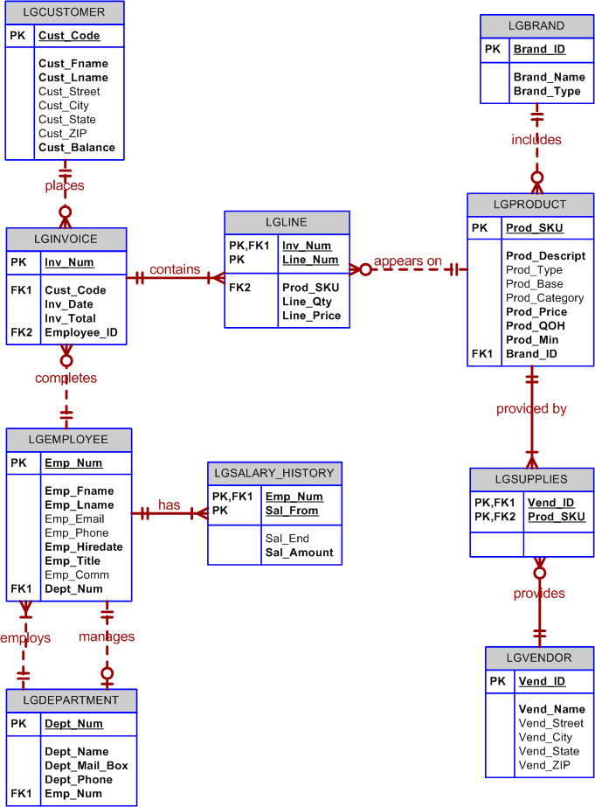

The database shown above is to be used for all of the problems in this homework assignment.

For each of the queries shown below, write an SQL expression that will return the correct results against the database shown above. Each problem is worth 20 points.

- Display all product information for those products that have a price greater than $50.00.
- Display all of the invoice numbers that were completed by the employee with id = 84078.
- Display the current salary for each employee in department 300. Assume that only current employees are kept in the system, and therefore the most current salary for each employee is the entry in the salary history with a NULL end date. Sort the output in descending order by salary amount.

- Display the starting salary for each employee. The starting salary would be the entry in the salary history with the oldest salary start date for each employee. Sort the output by employee number.

- Display the invoice number, line numbers, product SKUs, product descriptions, and brand ID for sales of sealer and top coat products of the same brand on the same invoice.

- The Binder Prime Company wants to recognize the employee who sold the most of their products during a specified period. Write a query to display the employee number, employee first name, employee last name, e-mail address, and total units sold for the employee who sold the most Binder Prime brand products between November 1, 2011, and December 5, 2011. If there is a tie for most units sold, sort the output by employee last name. (This is a complex query.)

- Display the customer code, first name, and last name of all customers who have had at least one invoice completed by employee 83649 and at least one invoice completed by employee 83677. Sort the output by customer last name and then first name.

- One of the purchasing managers is interested in the impact of product prices on the sale of products of each brand. Write a query to display the brand name, brand type, average price of products of each brand, and total units sold of products of each brand. Even if a product has been sold more than once, its price should only be included once in the calculation of the average price. However, you must be careful because multiple products of the same brand can have the same price, and each of those products must be included in the calculation of the brand’s average price.

- The purchasing manager is still concerned about the impact of price on sales. Write a query to display the brand name, brand type, product SKU, product description, and price of any products that are not a premium brand (brand type), but that cost more than the most expensive premium brand products.

