Number Systems – Binary, Decimal, and Hexadecimal

Basic Number Systems and Conversions

See Appendix A for a brief history of number systems.

Binary
- Base or radix 2 number system
- Binary digit is called a bit.
- Numbers are 0 and 1 only.
- Numbers are expressed as powers of 2.
- 2⁰ = 1, 2¹ = 2, 2² = 4, 2³ = 8, 2⁴ = 16, 2⁵ = 32, 2⁶ = 64, 2⁷ = 128, 2⁸ = 256, 2⁹ = 512, 2¹⁰ = 1024, 2¹¹ = 2048, 2¹² = 4096, 2¹² = 8192, …

Conversion of binary to decimal ( base 2 to base 10)
Example: convert (110011)₂ to decimal
= (1 x 2⁵) + (1 x 2⁴) + (0 x 2³) + (0 x 2²) + (1 x 2¹) + (1 x 2⁰)
= 32 + 16 + 0 + 0 + 2 + 1
= (51)₁₀

Conversion of decimal to binary (base 10 to base 2)
Example: convert (51)₁₀ to binary
51 ÷ 2 = 25 remainder is 1
25 ÷ 2 = 12 remainder is 1
12 ÷ 2 = 6 remainder is 0
6 ÷ 2 = 3 remainder is 0
3 ÷ 2 = 1 remainder is 1
1 ÷ 2 = 0 remainder is 1

Answer = 1 1 0 0 1 1
Note: the answer is read from bottom (MSB) to top (LSB) as 110011₂

Octal
- Base or radix 8 number system
- 1 octal digit is equivalent to 3 bits.
- Numbers are 0-7.
- Numbers are expressed as powers of 8. 8⁰ = 1, 8¹ = 8, 8² = 64, 8³ = 512, 8⁴ = 4096.

Conversion of octal to decimal ( base 8 to base 10)
Example: convert (632)₈ to decimal
= (6 x 8²) + (3 x 8¹) + (2 x 8⁰)
= (6 x 64) + (3 x 8) + (2 x 1)
= 384 + 24 + 2
= (410)₁₀

Conversion of decimal to octal (base 10 to base 8)
Example: convert (177)₁₀ to octal
177 ÷ 8 = 22 remainder is 1
22 ÷ 8 = 2 remainder is 6
2 ÷ 8 = 0 remainder is 2
Note: the answer is read from bottom to top as (261)₈, the same as with the binary case.

Hexadecimal
- Base or radix 16 number system
- 1 hex digit is equivalent to 4 bits.
- Numbers are 0-9, A, B, C, D, E, and F.
- (A)₁₆ = (10)₁₀, (B)₁₆ = (11)₁₀, (C)₁₆ = (12)₁₀, (D)₁₆ = (13)₁₀, (E)₁₆ = (14)₁₀, (F)₁₆ = (15)₁₀
- Numbers are expressed as powers of 16.
- 16⁰ = 1, 16¹ = 16, 16² = 256, 16³ = 4096, 16⁴ = 65536, …

Conversion of hexadecimal to decimal ( base 16 to base 10)
Example: convert (F4C)₁₆ to decimal
= (F x 16²) + (4 x 16¹) + (C x 16⁰)
= (15 x 256) + (4 x 16) + (12 x 1)
= 3840 + 64 + 12
= (3916)₁₀

Conversion of decimal to hex (base 10 to base 16)
Example: convert (77)₁₀ to hex
77 ÷ 16 = 4 remainder is D
4 ÷ 16 = 0 remainder is 4
Note: the answer is read from bottom to top as (4D)₁₆, the same as with the binary case.

Decimal | Binary | Octal | Hexadecimal
₀ | ₀₀₀₀ | ₀ | ₀
₁ | ₀₀₀₁ | ₁ | ₁
₂ | ₀₀₁₀ | ₂ | ₂
₃ | ₀₀₁₁ | ₃ | ₃
₄ | ₀₁₀₀ | ₄ | ₄
₅ | ₀₁₀₁ | ₅ | ₅
₆ | ₀₁₁₀ | ₆ | ₆
₇ | ₀₁₁₁ | ₇ | ₇
₈ | ₁₀₀₀ | ₁₀ | ₈
₉ | ₁₀₀₁ | ₁₁ | ₉
₁₀ | ₁₀₁₀ | ₁₂ | _{A}
₁₁ | ₁₀₁₁ | ₁₃ | _{B}
₁₂ | ₁₁₀₀ | ₁₄ | _{C}
₁₃ | ₁₁₀₁ | ₁₅ | _{D}
₁₄ | ₁₁₁₀ | ₁₆ | _{E}
₁₅ | ₁₁₁₁ | ₁₇ | _{F}

Figure 1 - Table of Binary, Decimal and Hexadecimal Numbers

Conversion of Octal and Hex to Binary

Conversion of octal and hex numbers to binary is based upon the the bit patterns shown in the table above and is straight forward. For octal numbers, only three bits are required. Thus 6₈ = 110₂, and 345₈ = 11100101₂. For hex numbers, four bits are required. Thus E₁₆ = 1110₂, and 47D₁₆ = 10001111101₂.

Conversion of Binary to Octal and Hex

Conversion of binary numbers to octal and hex simply requires grouping bits in the binary numbers into groups of three bits for conversion to octal and into groups of four bits for conversion to hex. Groups are formed beginning with the LSB and progressing to the MSB. Thus, 11100111₂ = 347₈ and 11100010101010010001₂ = 7025221₈. Similarly, 11100111₂ = E7₁₆ and 11000101010000111₂ = 18A87₁₆.

Binary Arithmetic

Binary Addition

+ | 0 | 1
0 | 0 | 1
1 | 1 | 10
Binary Addition Table

The entry for 1+1 is 10 which indicates a carry of 1

Examples

Addend 1011 1011 1011 1011 1011
Augend + 100 + 100 + 100 + 100 + 100

Sum 1 11 111 1111

carry 1 1 1 1
Addend 1101 1101 1101 1101 1101 1101
Augend + 1001 + 1001 + 1001 + 1001 + 1001 + 1001
Sum 0 10 110 0110 10110

Binary Subtraction
Uses the same principle of "borrowing" that decimal subtraction uses.

− | 0 | 1
0 | 0 | 1 (with a borrow from the next column)
1 | 1 | 0
Binary Subtraction Table

Example

borrow 01 01 01 0 0
Minuend 10100 10100 10100 10100 10100 10100
Subtrahend - 1001 - 1001 - 1001 - 1001 - 1001 - 1001
Difference 1 11 011 1011 01011

Note: This problem in decimal is 20 – 9 = 11 which is the answer we get in binary.

Octal Arithmetic

+ | 0 | 1 | 2 | 3 | 4 | 5 | 6 | 7
0 | 0 | 1 | 2 | 3 | 4 | 5 | 6 | 7
1 | 1 | 2 | 3 | 4 | 5 | 6 | 7 | 8
2 | 2 | 3 | 4 | 5 | 6 | 7 | 8 | 9
3 | 3 | 4 | 5 | 6 | 7 | 10 | 11 | 12
4 | 4 | 5 | 6 | 7 | 10 | 11 | 12 | 13
5 | 5 | 6 | 7 | 10 | 11 | 12 | 13 | 14
6 | 6 | 7 | 10 | 11 | 12 | 13 | 14 | 15
7 | 7 | 10 | 11 | 12 | 13 | 14 | 15 | 16
Octal Addition Table

Examples

carry 1
Addend 127 127 127 127
Augend + 42 + 42 + 42 + 42

Sum 1 71 171

carry 1 11 11 1
Addend 1777 1777 1777 1777 1777
Augend + 777 + 777 + 777 + 777 + 777
Sum 6 76 776 2776

Octal Subtraction

This is performed exactly like binary and decimal subtraction with the borrowing technique. Whenever the subtrahend is larger than the minuend, a 1 is borrowed from the next column.

Example:

Minuend 124 124 124
Subtrahend - 63 - 63 -63

Sum 1 41

Hexadecimal Arithmetic

Hexadecimal Addition

+ | 0 | 1 | 2 | 3 | 4 | 5 | 6 | 7 | 8 | 9 | A | B | C | D | E | F
0 | 00 | 01 | 02 | 03 | 04 | 05 | 06 | 07 | 08 | 09 | 0A | 0B | 0C | 0D | 0E | 0F
1 | 01 | 02 | 03 | 04 | 05 | 06 | 07 | 08 | 09 | 0A | 0B | 0C | 0D | 0E | 0F | 10
2 | 02 | 03 | 04 | 05 | 06 | 07 | 08 | 09 | 0A | 0B | 0C | 0D | 0E | 0F | 10 | 11
3 | 03 | 04 | 05 | 06 | 07 | 08 | 09 | 0A | 0B | 0C | 0D | 0E | 0F | 10 | 11 | 12
4 | 04 | 05 | 06 | 07 | 08 | 09 | 0A | 0B | 0C | 0D | 0E | 0F | 10 | 11 | 12 | 13
5 | 05 | 06 | 07 | 08 | 09 | 0A | 0B | 0C | 0D | 0E | 0F | 10 | 11 | 12 | 13 | 14
6 | 06 | 07 | 08 | 09 | 0A | 0B | 0C | 0D | 0E | 0F | 10 | 11 | 12 | 13 | 14 | 15
7 | 07 | 08 | 09 | 0A | 0B | 0C | 0D | 0E | 0F | 10 | 11 | 12 | 13 | 14 | 15 | 16
8 | 08 | 09 | 0A | 0B | 0C | 0D | 0E | 0F | 10 | 11 | 12 | 13 | 14 | 15 | 16 | 17
9 | 09 | 0A | 0B | 0C | 0D | 0E | 0F | 10 | 11 | 12 | 13 | 14 | 15 | 16 | 17 | 18
A | 0A | 0B | 0C | 0D | 0E | 0F | 10 | 11 | 12 | 13 | 14 | 15 | 16 | 17 | 18 | 19
B | 0B | 0C | 0D | 0E | 0F | 10 | 11 | 12 | 13 | 14 | 15 | 16 | 17 | 18 | 19 | 1A
C | 0C | 0D | 0E | 0F | 10 | 11 | 12 | 13 | 14 | 15 | 16 | 17 | 18 | 19 | 1A | 1B
D | 0D | 0E | 0F | 10 | 11 | 12 | 13 | 14 | 15 | 16 | 17 | 18 | 19 | 1A | 1B | 1C
E | 0E | 0F | 10 | 11 | 12 | 13 | 14 | 15 | 16 | 17 | 18 | 19 | 1A | 1B | 1C | 1D
F | 0F | 10 | 11 | 12 | 13 | 14 | 15 | 16 | 17 | 18 | 19 | 1A | 1B | 1C | 1D | 1E
Hexadecimal Addition Table

Examples

carry 0 00 00
Addend 3B2 3B2 3B2 3B2
Augend + 41C + 41C + 41C + 41C

Sum E CE 7CE

carry 1 1 1 1
Addend A27 A27 A27 A27 A27
Augend + C3B + C3B + C3B + C3B + C3B
Sum 2 62 662 1662

Hexadecimal Subtraction

Uses the same principle of "borrowing" that decimal and binary subtraction uses.

Example

borrow
Minuend 6E 6E 6E
Subtrahend - 29 - 29 -29

Difference 5 45

Minuend AC3 AC3 AC3 AC3
Subtrahend - 604 - 6 0 4 - 6 0 4 - 6 0 4

Difference F BF 4BF

Negative Numbers – Sign Magnitude and 2's Complement

Sign Magnitude

There are several alternative conventions that can be used to represent negative (as well as positive) integers, all of which involve treating the MSB as a sign bit. Typically, if the MSB is 0, the number is positive; if the MSB is 1, the number is negative. The simplest form of representation that employs a sign bit is the sign-magnitude representation. In an n-bit word, the right-most n-1 bits represent the magnitude of the integer, and the left-most bit represents the sign of the integer. For example, in an 8-bit word the value of +24₁₀ is represented by: 00011000₂, while the value of –24₁₀ is represented by 10011000₂.

There are several disadvantages to sign magnitude representation. One is that addition and subtraction operations require a consideration of both the signs of the numbers and their relative magnitudes to carry out the required operation. Another disadvantage is that there are two representations of 0. Using an 8-bit word, both 00000000₂ and 10000000₂ represent 0 (the first +0, the latter –0). This makes logical testing for equality on 0 more complex (two values need to be tested). Because of these disadvantages, sign-magnitude representation is rarely used in implementing the integer portion of the ALU.

Two’s Complement

Like sign-magnitude, two’s complement uses the MSB as a sign bit, thus making it easy to test if an integer is positive or negative. Two’s complement differs from sign-magnitude in the way the remaining n-1 bits (of an n-bit word) are interpreted. Two’s complement representation has only a single representation for the value of 0. The two's complement of a binary number is found by subtracting each bit of the number from 1 and adding 1.

Example

111
- 101 (binary representation of (5)₁₀)

010
+ 1
“011” (two's complement of (5)₁₀) [note the leading 0 is important]

Thus 011 is the twos complement of 101 or the representation of –5.

Example
10 – 6 = 4 in base 10
1010 − 110 = 100 in base 2
The two’s complement of 6 is 1010 over four bits
1010 + 1010 = 10100 since we are working with 4 bit numbers the MSB is discarded and we are left with 0100 where the MSB is 0 leaving a value of 100 which is binary representation of (4)_{10.}

An alternate way of performing a two’s complementation (does exactly the same thing the addition does without thinking about doing the subtraction and the addition) is as follows: beginning with the LSB and progressing toward the MSB, leave all 0 bits unchanged and the first 1 bit unchanged, after encountering the first 1 bit, complement all remaining bits until the MSB has been processed. The resulting number is the two’s complement of the original number.

Example: Consider the number 11100₂ (this is 28₁₀) The two’s complement is: 00100₂ achieved by:

MSB LSB
1 1 1 0 0 original number
0 0 1 0 0 two’s complement form

unchanged

complemented

Note that we get the same answer if we use the original technique.

1 1 1 1 1
- 1 1 1 0 0
0 0 0 1 1
+ 0 0 0 0 1

0 0 1 0 0

Operations with Negative Numbers

We will assume from this point forward that all negative numbers are represented in two’s complement form. The question then becomes, how do you know that you are dealing with a negative number when a result is produced? Consider the following example:

Example:
Suppose we have the expression 10 + (-8), with radix 10 numbers. Using five-bit numbers 10₁₀ is represented as 01010₂, and 8₁₀ is represented as 01000₂
The two’s complement of 01000₂ is 11000₂ (see previous example).
Performing the addition yields:

carry 1 1
0 1 0 1 0
+ 1 1 0 0 0

- 0 0 0 1 0

Note that a carry has occurred out of the MSB. In this case we are using 5-bit numbers, so the carry out of the MSB is simply ignored, and the correct answer of 2₁₀ has been calculated. What would have happened if we had been using 4-bit numbers instead of 5-bit numbers? Well, using 4-bit numbers the two’s complement of 1000₂ (this is 8₁₀) is exactly the same as the non-complemented form. Thus, the two’s complement of 1000₂ using four-bit numbers is also 1000₂. This means that you cannot tell the difference between +8₁₀ and –8₁₀ in four-bit binary words. This is explained in more detail later when we discuss overflow conditions (as a hint: notice in the example that both the addend and the augend have the same sign but the result (in four-bits) has a different sign).

carry 1 1
1 0 1 0
+ 1 0 0 0

- 0 0 1 0

The bit carried out of the MSB position, reflects that two number of the same sign were added together, yet the result has a different sign. This is reflects an overflow condition (see below).

Another Example:
Suppose we have the expression 4 + (-8), with radix 10 numbers. Using 5-bit numbers, 4₁₀ is represented as 00100₂, and 8₁₀ is represented as 01000_{2.} The two’s complement of 01000₂ is 11000₂.
Performing the addition yields:

carry
0 0 1 0 0
+ 1 1 0 0 0

1 1 1 0 0

Note that no carry has occurred out of the MSB. Since a two’s complement number was involved in the addition and no carry out of the MSB position occurred and the addend and augend are of different signs, this means that the result is valid and is in two’s complement form and thus represents a negative number. To determine what number this is you must uncomplement the result. The uncomplemented form is determined by complementing every bit (in a right to left pass through the two’s complement number) after the least significant 1 bit. In this case, the uncomplemented form will be (in five-bit form) 00100₂ which is 4₁₀, so the answer represents –4₁₀ which is the correct answer.

Why Two’s Complement?

Two’s complement arithmetic allows you to perform addition operations when subtraction is the actual desired operation. This means that any expression of the form: A – B can be computed as A + B_{C} where B_{C} represents the two’s complement form of B. This fact allows the Airthmetic Logic Unit (ALU) inside the CPU to be more compact since circuitry for subtraction is not included.

Although it may seem that with two’s complement we have found nirvana as far as representing negative numbers inside a computer is concerned, we unfortunately, have not. For any addition operation, the result may be larger than can be held in the word size of the system. This condition is called overflow. When an overflow occurs, the arithmetic logic unit (ALU) must signal the control unit (within the CPU) that an overflow condition exists and no attempt be made to use the invalid result. To detect overflow, the following rule must be observed:

If two numbers are added, and they are both positive or both negative, then overflow occurs if and only if the result has the opposite sign of the operands to the addition. Note that overflow can occur whether or not there is a carry out of the MSB position.

The following example illustrates an overflow condition.

Example:
Let A = 7₁₀ and B = -7₁₀.
Then the difference A – B (in radix 10) is: 7 – (-7) = 7 + 7 = 14.
In binary the value of B will be represented in two’s complement form as:
7₁₀ = 0111₂, -7₁₀ = 1001₂ since it is a negative number.
But since this is a subtraction problem we convert (the subtrahend) to its two’s complement form and perform an addition operation.
The two’s complement of 1001₂ (which represents –7₁₀) is 0111₂
The problem then becomes: 0111 + 0111 = 1110
Since the MSB is different in sign than A and B an overflow has occurred.

NOTE: Appendix B to this set of notes contains an explanation of how two’s complement numbers work from an alternative viewpoint that might be helpful in understanding the above problem with two’s complement numbers.

Circuit Diagrams for Half-Adders and Full-Adders

From the discussion of number systems above you have seen that binary addition differs from Boolean functions in that the output results will include a carry bit (term). However, addition in a digital computer can still be dealt with in Boolean terms. The following table, represents a truth table (in the Boolean function sense) for adding two input bits to produce a 1-bit sum bit and a carry bit. (Note the similarity of this table to that we gave above as the binary addition table.)

A | B | Sum | Carry
0 | 0 | 0 | 0
0 | 1 | 1 | 0
1 | 0 | 1 | 0
1 | 1 | 0 | 1
Table for Single-Bit Binary Addition

This truth table is easily implemented in digital logic, and appears below in a circuit defined as a half-adder.

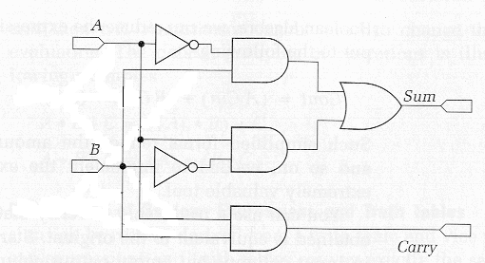
We aren’t interested in today’s computer systems in performing addition on just a single pair of bits (or a pair of 1-bit numbers). Rather, we need to be able to add two n-bit numbers. This is accomplished by putting together a set of adders so that the carry from one adder is provided as an input to the next. This scenario is shown schematically for a four-bit adder in the following diagram.

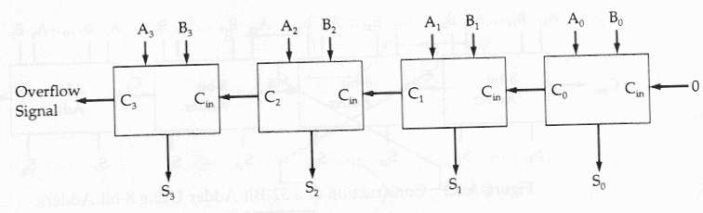

For a multiple-bit adder to work, each of the single bit adders must have three inputs, including the carry from the next-lower-order adder. The two outputs from the single-bit adders would be expressed as:

The truth table for this configuration is shown below.

C_{IN} | A | B | Sum | C_{OUT}
0 | 0 | 0 | 0 | 0
0 | 0 | 1 | 1 | 0
0 | 1 | 0 | 1 | 0
0 | 1 | 1 | 0 | 1
1 | 0 | 0 | 1 | 0
1 | 0 | 1 | 0 | 1
1 | 1 | 0 | 0 | 1
1 | 1 | 1 | 1 | 1
TruthTable for Modified 1-bit Adder

Appendix A – A Brief History of Number Systems

The concept of the number and the process of counting developed so long before the time of recorded history that the manner of this development is largely conjecture. Math historians have surmised that development occurred as the result of a primitive tribe desiring to know how many members it had and how many enemies it opposed. Ancient shepherds wanted to know if their flock was decreasing in size. Probably among the earliest method for keeping a count was by some simple tally method, employing the principle of one-to-one correspondence. Through the use of sticks, stones, notches in wood, knots in rope, or fingers, the tribe could keep track of its members or possessions.

As time passed and it became necessary to make more extensive counts, the counting process needed to be systematized. By arranging the numbers into convenient basic groups, our early ancestors introduced the concept of number bases. There is anthropological evidence that three and four served as primitive number bases. Today, some South American tribes count by hands, or base five. There is also evidence that base 12 was used as a pre-historic number system used mainly in relation to measurements. The American Indian and Mayan tribes used a base 20 number system. The ancient Babylonians used a number system based on 60. This number system is still used today when measuring times and angles in minutes and seconds.

The number system that you are probably most familiar with, the decimal system (base 10) appeared first in India about 500 A.D. This system undoubtedly resulted from finger counting.

The world’s first electronic computer, the ENIAC (Electronic Numerical Integrator And Computer) used the decimal number system internally. The binary number system was not the number system of computers until 1945 when John von Neumann presented the world with his stored program concept for the digital computer, which incorporated the base 2 number system. The binary number system is suitable to digital computers for the following reasons:

- Simplification of the arithmetic circuitry.
- Provides a simple “code” in which to store information and instructions.
- Provides reliability.

The number systems of octal and hexadecimal are used primarily as a shorthand notation when dealing with the memory dumps (typically available in binary, octal, or hex), assembly level instruction codes and machine code that system level programmers.

APPENDIX B – Geometric Depiction of Two’s Complement Integers

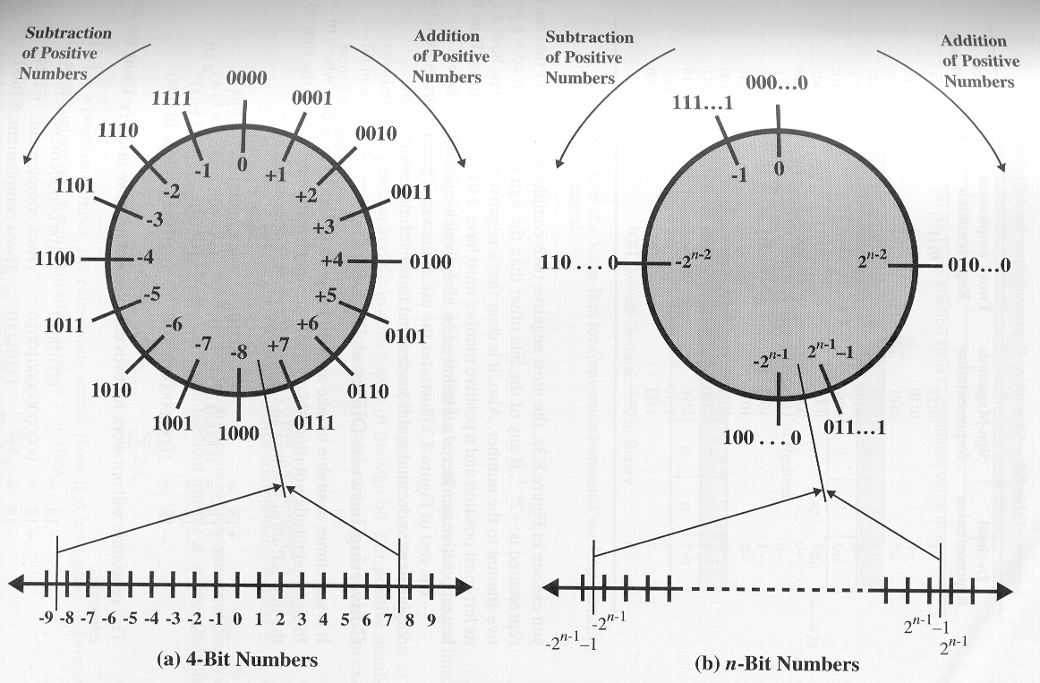
The geometric depiction of two’s complement numbers may help you to understand how overflow conditions can be determined using this representation for negative numbers. First consider the case of 4-bit integers as shown in part (a). The circle in the upper part of the diagram is formed by selecting the appropriate segment from the number line and joining the endpoints. Using 4-bit integers, two’s complement form allows us to represent the numbers between –8₁₀…+7₁₀ (inclusive). Starting at any point on the circle, you can add positive k (or subtract negative k) to that number (the starting point number) by moving k positions clockwise. Similarly, you can subtract positive k (or add negative k) from that number by moving k positions counter-clockwise. If an arithmetic operation results in traversal of the point where the endpoints are joined, an incorrect answer will result. The diagram in part (b) represents the general case for n-bit integers.
Appendix C – Nine’s Complement

Since you are most familiar with the decimal number system, the question might arise if you can perform subtraction via addition using the complementation technique. The answer is yes, but with the decimal number system you use a nine’s complement. The nine’s complement of a number is found by subtracting the number from a number that consists of all 9’s. The technique is illustrated below.

Forming the 9’s complement

Given 365₁₀ , it’s nine’s complement is: 999 – 365 = 634₁₀

Given 34₁₀ , it’s nine’s complement is: 99 – 34 = 65₁₀

Subtraction as an Addition Operation

842 using 9’s complement: 842
-365 +634

477 1476 end-around-carry

+ 1

477 answer in base 10

When the larger number is subtracted from the smaller number, no end-around carry will result, but the answer will be in nine’s complement form and of the opposite sign.

152 using 9’s complement: 152
-290 +709
-138 861
no carry is produced so the answer is in
9’s complement form and of the opposite
sign. So the answer is:

999
-861

-138

