Performance Categories
of Algorithms

- Sublinear - O(logN)
- Linear - O(N)
- Nearly linear - O(NlogN)
- Quadratic - O(N²)
- Exponential - O(2^{N})
O(N!)
O(N^{N})

An Exponential Algorithm

Towers of Hanoi Problem: involves moving a specified number of disks (N) that are all different sizes from one tower to another.
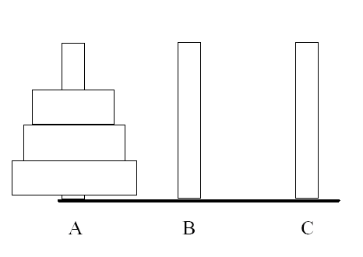
void tower(int n, char start, char finish, char temp)
{
if (n == 1)
printf(“Move from %c to %c\n”, start, finish);
else {
tower(n-1, start, temp, finish);
printf(“Move from %c to %c \n”, start, finish);
tower(n-1, temp, finish, start);
}
}
Towers of Hanoi – Runtime

- For 3 rings - 7 operations
  - Cost = (2^{N}) – 1
- Each time we increment N by 1, we double the amount of work
- Run-time trace of function tower with 4 disks:
Original call with
n = 4
Call with
n = 3
Call with
n = 3
Call with
n = 2
Call with
n = 2

Call with
n = 2

Call with
n = 2

Call with
n = 1

Call with
n = 1

Call with
n = 1

Call with
n = 1

Call with
n = 1

Call with
n = 1

Call with
n = 1

Call with
n = 1

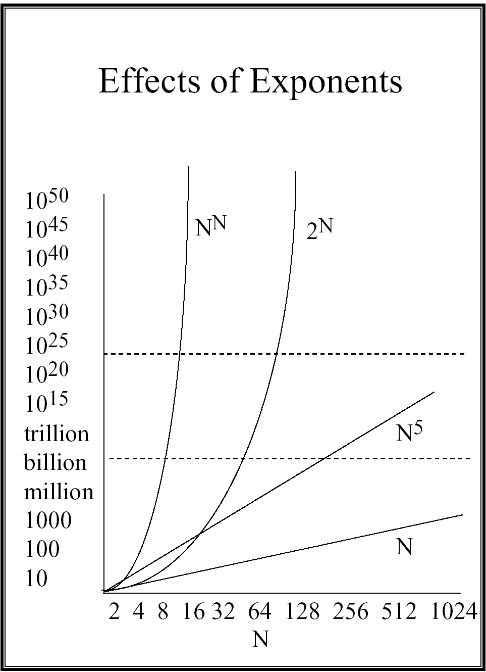
Effects of Exponents

Consider Towers of Hanoi (or other 2^{N} algorithm) for N of only 256:

Time cost is a number with 78 digits to
the left of the decimal.

For comparison:
• Number of microseconds since the Big Bang: a number with 24 digits.
• Number of protons (est’d) in the known universe: a number with 77 digits.
Reasonable vs Unreasonable

Reasonable Algorithms...
• Have N only as a polynomial factor
- O (logN)
- O (N)
- O (N^{K}) where K is a constant

Unreasonable Algorithms...
• Have N as an exponential factor
- O (2^{N})
- O (N!)
- O (N^{N})

Example Problems

- Algorithm A runs in O(N²) time, and for an input size of 4, the algorithm runs in 10 milliseconds, how long can you expect it to take to run on an input size of 16?

- Algorithm A runs in O(log₂N) time, and for an input size of 16, the algorithm runs in 28 milliseconds, how long can you expect it to take to run on an input size of 64?

- Algorithm A runs in O(N³) time. For an input size of 10, the algorithm runs in 7 milliseconds. For another input size, the algorithm takes 189 milliseconds. What was that input size?

- For an O(N^{k}) algorithm, where k is a positive rational number, a friend tells you that instance of size M took 16 seconds to run. You run an instance of size 4M and find that it takes 256 seconds to run. What is the value of k?

- Algorithm A runs in O(N³) time and Algorithm B solves the same problem in O(N²) time. If algorithm A takes 5 milliseconds to complete for an input size of 10, and algorithm B takes 20 milliseconds for an input size of 10, what is the input size that you expect the two algorithms to perform about the same?

- For an O(N³) algorithm, an instance with N = 512 takes 56 milliseconds. If you used a different-sized data instance and it took 7 milliseconds how large must that instance be?

Answers

- Algorithm A runs in O(N²) time, and for an input size of 4, the algorithm runs in 10 milliseconds, how long can you expect it to take to run on an input size of 16?

4² 16²
----- = ------- => x =160ms
10ms x

- Algorithm A runs in O(log₂N) time, and for an input size of 16, the algorithm runs in 28 milliseconds, how long can you expect it to take to run on an input size of 64?

log 16 log64
------------ = ------------ => x =42 ms
28 ms x

- Algorithm A runs in O(N³) time. For an input size of 10, the algorithm runs in 7 milliseconds. For another input size, the algorithm takes 189 milliseconds. What was that input size?

10³ N³
----- = ------- => N = 30
7 ms 189

- For an O(N^{k}) algorithm, where k is a positive rational number, a friend tells you that instance of size M took 16 seconds to run. You run an instance of size 4M and find that it takes 256 seconds to run. What is the value of k?

M^{k} (4M)^{k} 256
------- = ---------- => 4^{k} = -------- => k = 2
16 ms 256 16

- Algorithm A runs in O(N³) time and Algorithm B solves the same problem in O(N²) time. If algorithm A takes 5 milliseconds to complete for an input size of 10, and algorithm B takes 20 milliseconds for an input size of 10, what is the input size that you expect the two algorithms to perform about the same?

For algorithm A: O(N³) means
execution time ≤ c1 * N³
for N = 10 execution time is 5ms = c1 * 10³
so , c1 = 5 / 10³

For algorithm B: O(N²) means
execution time ≤ c2 * N³
for N = 10 execution time is 20 ms = c2 * 10²
so , c2 = 20 / 10²

what is N for which
c1 * N³ = c2 * N²

Substitute for c1 and c2:
5 / 10³ * N³ = 20 / 10² * N²
=> N = 40

- For an O(N³) algorithm, an instance with N = 512 takes 56 milliseconds. If you used a different-sized data instance and it took 7 milliseconds how large must that instance be?

512³ N³
----- = ------- => N =256ms
56ms 7

7. What is the computational complexity of the following algorithm?

int N,j,k,sum = 0;

scanf(“%d”,&N);

for(j=0; j < N; j++){

for(k=0; k < j; k++) {

sum = sum + j * k;

}
}

8. What is the computational complexity of the following algorithm? (Assume N is a positive integer)

int N,j,k,sum = 0;

scanf(“%d”,&N);

j = N;

while (j > 1) {

k = 0;

while (k > N){

sum = sum + j * k;
k ++;

}
j = j / 2;
}

Binary Trees

Given the following postorder and inorder traversals of a binary tree, draw the tree.

Postorder: ABCDEFIKJGH
Inorder: CBAEDFHIGKJ

An Application of Binary Trees

Contemporary compilers make use of tree structures in obtaining forms of an arithmetic expression for efficient evaluation:

Example: Binary expression tree for
(A-B) + C * E/F

+

-
/

A
B
*
F

C
D

Inorder traversal gives infix form
Preorder traversal gives prefix form
Postoredr traversal gives postfix form

Exercise 1:

Consider the following node structure:
struct node {
dataType data;
struct node *left;
struct node *right;
}

What is the output produced by the following function for the pictured tree?

void treewalk(struct node *tree)
{
if (tree == NULL)
printf(“OOPS\n”);
else{
treewalk(tree->right);
treewalk(tree->left);
print(tree->data);
}
}

A

B

C

D

E

F

G

H

I

J

tree

Exercise 2:

a) Insert the following names into a binary search tree and draw the resulting tree.

JONES
BILL
DAVE
MARY
LARRY
PAUL
PENNY
KATY
LEO
MIKE
BETTY
DON
ROGER
TOM

b) Delete JONES, PENNY, MARY

QUEUES

Consider the circular array implementation of queues. In this implementation limit the number of items in the queue to one less than the number of elements in the array (i.e. always keep one empty element at the end of the queue). Using this solution, determine the conditions for checking whether the queue is empty or full.
Adopt the following conventions for the front and rear: front is to point at the next item to be removed from the queue. rear is to point at the next available location, that is the next location to be filled. As an illustration, the following is a queue with three items:

0 | 1 | 2 | 3 | 4 | 5
A | B | C

front rear

Given the following declarations for the queue :

#define SIZE 100
struct queue{
int items[SIZE];
int front;
int rear;
};
Write down the functions isEmpty(), isFull() and enqueue().
a) isEmpty() :
int isEmpty(struct queue q){

}

b) isFull():

int isFull(struct queue q){

}

c) enqueue():
void enqueue (struct queue *q, int item){

