COP 3502
Computer Science I

Section 2

Instructor: Nihan Cicekli
Office: CSB 234
Email: nihan@cs.ucf.edu
Office Hours: TR 1:30-3:30pm

Course web page:

http://www.cs.ucf.edu/courses/cop3502/nihan

Course Information

Textbook: The Art and Craft of Computing, S. Ceri, D. Mandrioli, L. Sbattella, Addison-Wesley, 1998.

Recommended text: Problem Solving and Program Design in C, J. R. Hanly and E. B. Koffman, Addison-Wesley, 4th edition, 2001.

Prerequisite: COP 3223 - C Programming

All students registered for COP 3502 must also be enrolled in a recitation section: COP 3502L

The recitation sections (COP 3502L) will be used to provide assistance with programming or homework assignments, further explanation of lecture topics and presentation of material related to the classroom lectures. You will also take quizzes in the recitation sections that will consist of questions or problems that cover recent recitation or lecture topics or assignments.

Grading:
There will be a total of 100 points, distributed as follows:

Two exams (20% each) 40%
Final exam 30%
4 quizzes 10%
4 assignments 20%

Important Note: You are expected to be proficient in the C programming language. You will be required to program in C for all of your programming assignments.

Grading Conditions:

- Unless you make other arrangements with your TA, assignments are to be handed in during lab only. A late assignment will receive a 25% deduction from the grade it would have received if turned in on time. The last assignment may not be turned in late.

- 4 quizzes will be given during the semester. If you have a conflict with a quiz, you may make it up beforehand. (You may only receive a makeup quiz if you make an arrangement with the lecturer BEFORE the quiz is given in recitation.)

- You may receive a makeup exam only if you have a legal excuse (e.g. medical report) and you inform the lecturer BEFORE the exam.

- The instructor reserves the right to change the grading policy at any time, but will not make the requirements more stringent than those stated here.

- All assignments, quizzes and programs are to be your own work. No group projects or assignments are allowed.

- A schedule of lecture topics, exam dates, quiz dates and assignment due dates will be provided.

- Check the course web page (see above) frequently for updates and additional information.

Course Objectives

- Provide an introduction to the field of computing: The central concept that underlies computer science is the algorithm and thus algorithms are made the central object of study.

- Provide Conceptual Content and Software Skills: The lecture component focuses on conceptual tools for constructing and analyzing algorithms, while the lab component focuses on programming applications.

- Prepare students for programming: Essential algorithmic concepts and techniques are introduced. A number of programming assignments are given.

Course Content

- Basics of Algorithmic Design
- Review of C: statements, data types
- Review of C: Functions, files
- Recursion
- Arrays and Sorting
- Dynamic Memory Allocation
- Linked Lists
- Stacks and Queues
- Binary Trees
- Algorithmic Complexity

Overview of Algorithms

Computers are devices that do only one kind of thing:
They carry out algorithms to process information.

To computer scientists, the algorithm is the central unifying concept of computing, the mode of thought that is the core of the computing perspective.

ALGORITHM

• A set of logical steps to accomplish a task.

• A “recipe of action”.

• A way of describing behavior.

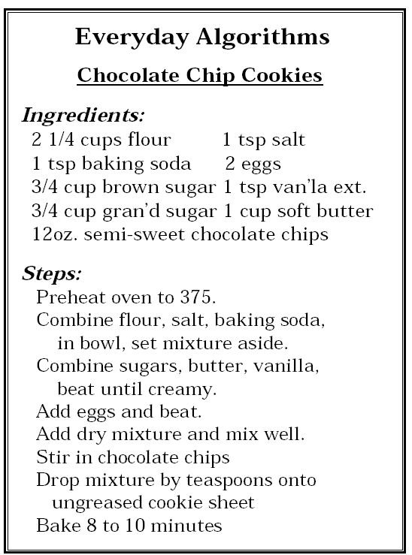

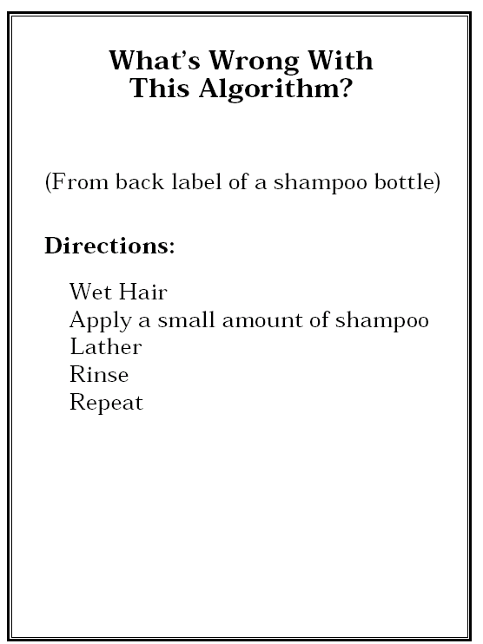
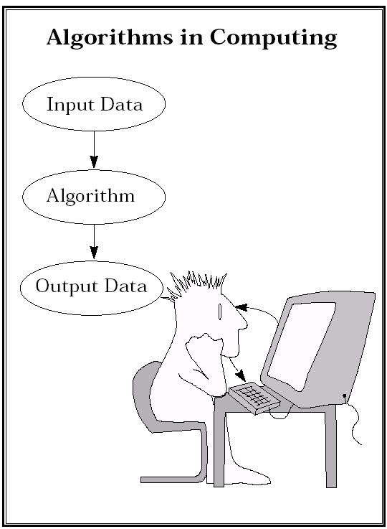

To be useful, an algorithm must
- accept input data,
- process that data in some way and
- output the results.

However, to be a correct algorithm, it must correctly solve the problem for any valid input data. Also, for the same input data, it must always give the same answer. Invalid input data should produce an error message or some other indication that the algorithm cannot correctly solve the problem. It should not produce an answer when given incorrect data since the user will think that the answer is valid.

Successful algorithms must consider all possible cases presented by acceptable data.

You will succeed more quickly at constructing algorithms if you make it a habit to
- think about the problem and its data, then
- enumerate all the special cases that the algorithm must handle.

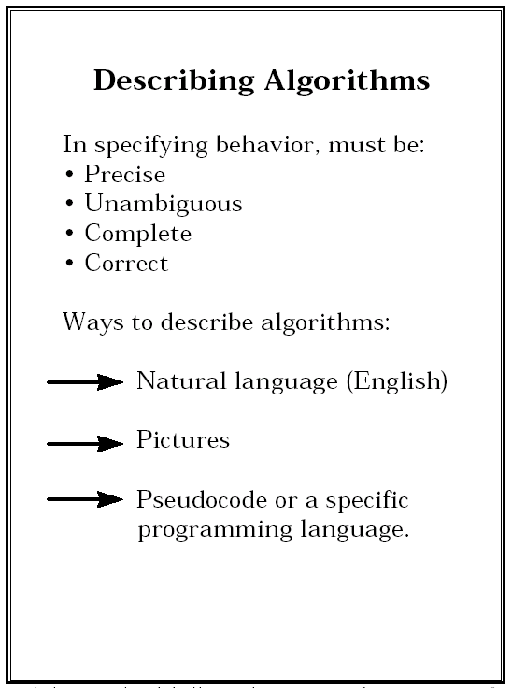
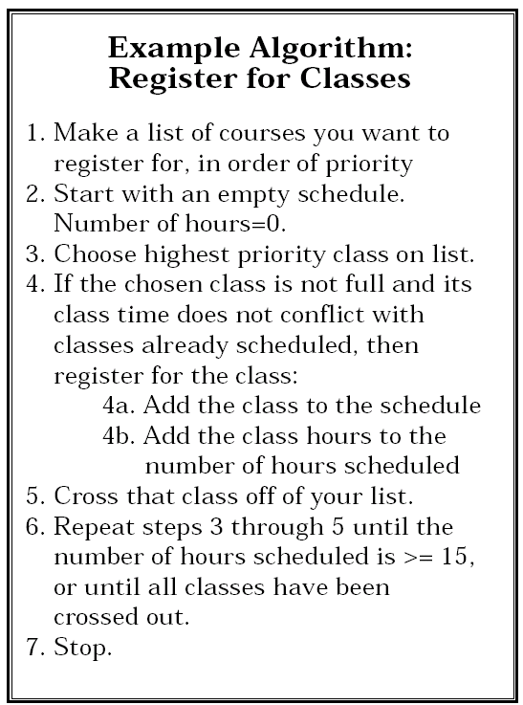

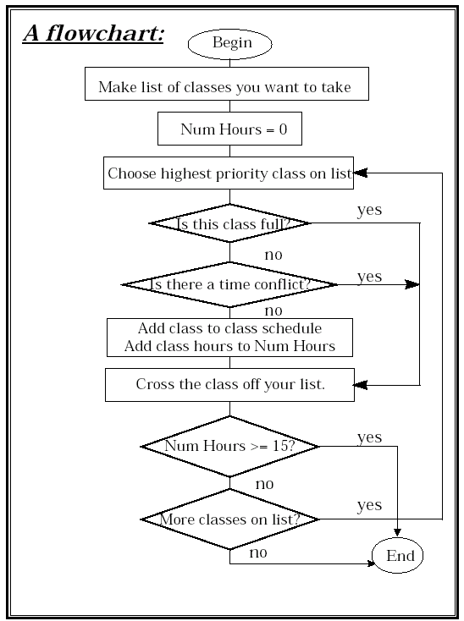

Properties of good algorithms

1. Precision
- each step must be clear and unambiguous in its meaning
- the order of execution of the steps must be clear
- the number of steps must be finite
- each step must itself be finite

2. Simplicity
- each step must be simple enough that it can be easily understood
- each step should translate into only a few (or one) computer operation or instruction

3. Levels of abstraction
- the steps in the algorithm should be grouped into related modules or blocks
- you may use one module inside another module
- you may refer to other algorithms by name instead of including all of their steps in the current algorithm

Abstraction

In Computer Science:

- Abstraction refers to the LOGICAL GROUPING of concepts or objects.

- We focus on general characteristics instead of concrete realities, specific objects or actual instances

- Define/implement the general idea, isolate the details

Well-designed algorithms will be organized in terms of abstraction. This means that we can refer to each of the major logical steps without being distracted by the details that make up each one. The simple instructions that make up each logical step are hidden inside modules. These modules allow us to function at a higher level, to hide the details of each step inside a module, and then to refer to that module by name whenever we need it.

By hiding the details inside appropriate modules, we can understand the main ideas without being distracted. This is a key goal of using levels of abstraction:
- Each module represents an abstraction. The name of the module describe the idea that the module implements. The instructions hidden within the module specify how that abstraction is implemented.
- We can see what is being done (the idea) by reading the descriptive name of the module without having to pay attention to how it is being done.
- If we want to understand how it is being done, we can look inside the module to find out.

Levels of Abstraction

Example : A pie recipe

1. Prepare blueberry filling
2. Prepare crust
3. Fill crust
4. Top pie with lattice crust
5. Bake at 350 for 45 minutes
6. Cool and serve

module Prepare blueberry filling
.
.
.

module Prepare crust
.
.
.
Problem: Drinking a glass of milk.

Algorithm:
- Enter the kitchen
- Get a glass
- Get the milk from the refrigerator
- Fill the glass with milk
- Drink it

Refine step 1:
1.1. Walk to the kitchen door
1.2. If the door is closed

1.2.1. Open it
1.3. Walk into the kitchen

Refine step 3:
3.1. Open the refrigerator
3.2. Get the milk
3.3. Close the refrigerator

Refine step 4:
4.1. while the glass is not full
4.1.1. Pour some milk into the glass
Computational Abstractions

Problem: Calculating a letter grade for the course, based on a student’s various numerical scores (exam, quiz, and hw) and on the weights assigned to each

Inputs: Student’s name, hw average, quiz average, exam score, their respective weights
Output: Letter grade for the student

Algorithm Calc_Grade:

1. Get data(student_name, hw_avg,quiz_avg,exam_score)
2. num_grade = Calc_Avg(hw_avg, quiz_avg, exam_score).
3. letter_grade = Calc_Ltr_Grade(num_grade)
4. Output_Grade(student_name,letter_grade)

Software Development
Steps of developing software to solve a problem:

- Problem Understanding
- Read the problem carefully and try to understand what is required for its solution.

- Analysis
- Identify problem inputs and outputs.

- Design (Top-down design)
- Map out the modular structure of your algorithm.
- Refine your modular design. Give a descriptive identifier for each module. Does each module do only one logical task? Subdivide any module that does not, as many times as necessary.
- Define the interface of each module before writing any code.
- Begin the bottom-up work of constructing each module.

- Implementation
- Implement the algorithm as a (C) program.
- Convert steps of the algorithm into programming language statements.

- Testing and Verification
- Test the completed program, and verify that it works as expected.
- Use different test cases (not one) including critical test cases.
Algorithm Components

- Data structures to hold data.
- Data manipulation instructions to change data values.
- Conditional expressions to make decisions
- Control structures to act on decisions.
- Modules to make the abstraction manageable by abstraction.

Data Structures

Data are the representations of information used by an algorithm. This includes:
- Input data
- Output data
- Any interim data generated by the algorithm for its own internal use.

Data structures are “containers” for data values.
- Variables
e.g. The average of student grades (real number)
The number of classes enrolled (integer)
- Constants
e.g. the number pi
tax rate
- Complex data structures: special data organization tools that help us solve the problem at hand more efficiently.
e.g. lists, records (structures), arrays

Data Structures (cont.)

For distinguishing and referral purposes we give each data structure a name.

The names should be descriptive of the data.

e.g. Total amount to be paid : Balance
(but not Fred)
The number of hours worked: NumHrs

The descriptive names we use for data structures are called identifiers.

Data Manipulation Instructions

Instructions allow the algorithm to

- obtain data values from the world and store them in data structures.

- manipulate those values via arithmetic operations, copying the contents of one data structure to another, etc.

- output the resulting values back to the world.
Conditional Expressions

A computer can make decisions. The ability of an algorithm to make decisions and act on them is what makes algorithms (and computers) powerful.

All such decisions are based on conditional expressions that are either true or false.
e.g. age == 20
salary > 100,000
grade == ‘A’
salary > 100,000 && age == 20

Control Structures

They allow an algorithm to act on the decisions it makes.
e.g.
if (class is not full)
Add the class to the schedule

while (there are still data)
read data
store data
Modules

Algorithms can become very complex and we don’t want an algorithm to be a big sequential list of steps.

Simply placing all components of the algorithm together will make them hard to understand, repair and extend.

Instead modules are used to group logically related data and instructions. Modules raise the level of abstraction. Thus they allow
- Clearer thinking
- Faster repairs
- Easier modifications

Exercise

Write an algorithm to find the minimum of three numbers.

- Problem Understanding
- Analysis: What are the inputs and outputs?
- Design: How to solve the problem.
- Implementation: in C
- Verification and Testing.
Input: three numbers
Output: the minimum value

Algorithm1:
1. Read three numbers into a, b and c.
2. Keep a variable to hold the minimum value.
3. if (a < b) then min ← a
else min ← b
4. if (c < min) then min ← c
5. Print min.

Algorithm2:
1. Read three numbers into a, b and c.
2. if (a < b) and (a < c) then print a
else if (b < c) then print b
else print c.

Some problems to think about

- You are given a set of 3 weights: w1, w2, and w3 in increasing order of weight. You want to determine if some combination of those weights can add up to a specified weight w. Have your algorithm return true if its possible or false otherwise.

- You are given a list of items. In the list, each item has a price and a particular tax rate. Compute the total that would be spent buying all of these items, including tax.

- You are given an integer. Compute if the number is prime or not. (A prime number is one that has no other divisors other than 1 and itself. You may assume that in a single step you can determine if one number divides another evenly or not.)

- You are given a list of activities that a person does in a day. In addition to the particular activities, you are given how long they do each activity(in hours) and how many calories per hour that activity burns. Assuming that for all hours in the day not listed, the person burns 50 calories an hour, compute the total number of calories burned in a 24 hours period. (You may assume that the activities on the list add up to less than 24 hours.)

Computer Architecture

Computer hardware consists of five main components:
- Memory
- Central Processing Unit (CPU)
- Input Devices
- Output Devices
- Secondary Storage

Memory

CPU
Secondary Storage
Input Device
Output Device

Memory
- Store information (data + instructions)
- A sequence of memory cells.
- a byte is 8 bits
- a bit is the smallest unit (0 or 1)
- Store, retrieve, update
- changing the pattern of 0 and 1s in memory cells
- copying these patterns into some internal registers
- Stored information in memory is volatile.

CPU (Central Processing Unit)
- Process and manipulate information stored in memory.
- It can be divided into two units: CU (Control Unit) and ALU (Arithmetic Logic Unit)
- CU coordinates activities of the computer and controls other devices of computer.
- ALU processes arithmetical and logical instructions.

Input and Output Devices
- Provide the interface between the user and the computer.
- Input devices are used to enter instructions or data by the user.
- Output devices are used to give results of computations.
- Input Devices: keyboard, mouse
- Output Devices: monitor, printer

Secondary Storage
- Computers have limited main memory and information stored in main memory is volatile. i.e. when a computer is switched off, information in its main memory disappears.
- There are additional data storage units, called secondary storage devices.
- Data stored in these secondary storage devices are permanent, i.e. data does not disappear when you switch off the computer.
- Some secondary storage units:

Floppy Disks, Hard Disks, Tape Drive, Optic Disk (CD Drive)

Software

Operating System
- Controls all machine activities
- Provides the user interface to the computer.
- Manages resources such as CPU and memory
- Widows 95, Widows 98, Solaris, Unix

Application Program
- generic form for all other kind of software
- games, word processors, compilers, etc.

INTERNET

A network is two or more computers connected together so that information and resources can be shared.
- each computer has its own network address which uniquely identifies it among the others.
- for example, computers in a network can share a printer.

A file server is a network computer dedicated to storing programs and data that are shared among network users. A file server often has a large amount of secondary memory (hard disk).

Computers in a network communicate using a communication line. Design of this communication line can be different.

A local-area network (LAN) is designed to cover small distances and a small number of computers.
- A LAN often connects the machines in a single room or building (or a couple of buildings).

A wide-area network (WAN) connects two or more LANs often over long distances.

The Internet is a WAN which spans the entire planet.

The word Internet comes from the term internetworking, which implies a network networks.

The software which manages Internet communication is called TCP/IP.
- The information which will be sent is formatted according to the Internet Protocol (IP) (by the programs in IP).
- Then they are reassembled by the programs in the Transmission Control Protocol (TCP).

Most computers have a unique Internet name, which is also referred as an Internet Address.
- Example, eola.cs.ucf.edu (eola is the name of the machine, cs is a subdomain (network) at ucf.edu.
- edu - educational institution, com – commercial institution, org – non-profit organization, gov – goverment

E-mail address: a user in a certain domain will have an e-mail address.
Example,
- nihan@cs.ucf.edu
- nihan@ceng.metu.edu.tr

World-Wide-Web

The World-Wide-Web (WWW) allows many different types of information to be accessed using a common interface (it uses Internet).

A browser is a program which accesses and presents information in different formats such as text, graphics, sound, programs, etc. Two popular browsers: Microsoft Internet Explorer, Netscape.

Web pages are defined by the HyperText Markup Language (HTML).
- It may have links to pictures, sound, graphics, other web pages.

Information on the Web is found using a Uniform Resource Locator (URL)
http://www.cs.ucf.edu
http://www.cs.ucf.edu/~nihan

A URL may indicate an HTML document, or some other kind of information. Browser knows what to do depending on the type of document.
Data and Computers

All data (numbers, alphabetic characters, images, sounds, movies, etc.) are stored as binary numbers in a computer.

What are binary numbers?
Binary is a base 2 number system. Binary numbers only have two digits to work with, 0 and 1, and make all numbers by grouping one or more of those two digits together.
e.g.
Decimal number Binary number
5 101
12 1100
156 10011100

Decimal number system is base 10. (i.e. it has 10 digits to represent the numbers)

e.g. The decimal number 3816 represents a specific value. We can calculate that value as:

3 * 1000 + 8 * 100 + 1 * 10 + 6 * 1
or as:
3 * 10³ + 8 * 10² + 1*10¹ + 6*10⁰

Binary numbers
Binary numbers are represented in a similar form.
e.g. The value of the binary number 1101 can be calculated as:

1*2³ + 1* 2² + 0*2¹ + 0*2⁰
or as:
1 * 8 + 1 * 4 + 0 * 2 + 1 * 1 = 13

The decimal number 3816 can be converted into the binary number 111011101000.

Notice that we need 12 binary digits to store a 4 digit decimal number. In fact, it takes 20 binary digits to store any 6 digit decimal integer and 30 binary digits to store decimal integers up to 1 billion.

This means that we must set aside large portions of the computer's memory to have room to store numbers that we will use in calculations.

It is also important to know that we can find the power of 2 that is equal to a given number. We take the logarithm of the number, base 2.
e.g.
log₂16 = 4 since 2⁴ = 16.

You may find it useful to memorize the first few powers of 2 so you don't have to calculate them when you need to convert binary numbers to decimal or find a logarithm base 2.

2⁰ | 2¹ | 2² | 2³ | 2⁴ | 2⁵ | 2⁶ | 2⁷ | 2⁸ | 2⁹ | 2¹⁰ | 2¹¹
1 | 2 | 4 | 8 | 16 | 32 | 64 | 128 | 256 | 512 | 1024 | 2048

Storing other types of data

Character Codes
Alphabetic characters are represented by specific patterns of binary numbers called character codes. There are a number of different character code standards that have been used in computers, but the most common for personal computers is ASCII (American Standard Code for Information Interchange).

ASCII is an 8-bit code, i.e. it uses patterns that are 8 bits long to represent a single character. This allows a total of 256 different bit patterns and that is enough for all of the characters found on computer keyboards, plus some special patterns that are used for control codes .

Sample ASCII codes for characters:

Character Decimal number Binary representation
‘A’ 65 01000001
‘B’ 66 01000010
‘a’ 97 01100001
‘$’ 36 00100100
space 32 00100000

Strings
They are simply stored as a sequence of character codes.

H e l l o !
01001000 01100101 01101100 01101100 01101111 00100001

Program Instructions

Computers cannot read program instructions written in a high-level programming language. The instructions must be translated into a form that the computer can understand.

How are computer programs stored?

Instructions must also be stored as binary numbers. The specific binary numbers that represent steps in a program are built into the computer's Central Processing Unit (CPU) by the designers. These binary numbers are referred to as the computer's machine code because it is a code that the machine understands. Machine codes are usually different for each type of CPU, thus different types of computers can't run each other's programs. We need to understand that each machine code number tells the CPU to perform a single, simple instruction like adding two numbers or comparing two numbers to see if they are equal. The program that you write in a language like C is translated into these simple binary codes and they are stored in a disk file so they can be executed later.

How are instructions executed?
The CPU contains several components that help it execute instructions. It has a number of internal memory locations, called registers that are used for temporary storage.

It has special electrical circuits that can add or subtract numbers, compare the value of two numbers or perform other math-related operations.

It has two special registers, the Instruction Register and the Program Counter (or instruction counter). The Instruction Register (IR) is used to hold the machine code instruction that is currently being executed. Each instruction must be copied into the IR so that the CPU can decode it and set switches in its circuits to perform the operation that it specifies. The Program Counter (PC or IC) is used to indicate the next instruction that will be executed. Therefore, each time an instruction is completed, the CPU knows where to get the next one.

The basic operation of the CPU can be reduced to the following three steps, which are repeated until the program has finished or an error occurs:
- fetch - copy the next instruction to be executed into the IR
- increment - change the PC so that it points to the next instruction to be executed
- execute - decode and perform the instruction in the IR
This is called the machine cycle (or the instruction cycle) and is fundamental to the operation of the computer.

