How to access Eustis Account, Transfer Files to the server and Some Common UNIX Commands

Common UNIX Commands
You can find several tutorials on UNIX online. Some of my favorites are:
http://www.ee.surrey.ac.uk/Teaching/Unix/
http://www.bcrl.stcloudstate.edu/node/7 (has link to many other tutorials)

Using PuTTY with UCF Eustis

- In order to connect to Eustis, you first need to download PuTTY from helpdesk website (or internet).
- Run PuTTY which will open up the following window.
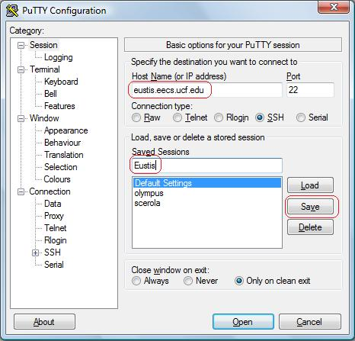
In the Host Name (or IP address) text box type the name of the UCF Eustis Server “eustis.eecs.ucf.edu”. Port 22 is selected by default and so is SSH. You cannot Telnet into Eustis anymore because of security reasons. Next in Saved Sessions text box type the name that you want for your SSH connection e.g., “Eustis”. Finally click Save. This will allow you to just click on Eustis the next time that you log in and click load. Finally click Open and you are ready to connect.
- When you click open in the PuTTY Configuration window the shell will open prompting you for a user name and password. Your User Name is your NID, and password by default is PYYMMDD. For Example if your birthday is July 4, 1980 then you would enter P800704 as your password. Once you have logged in you should get the following screen:
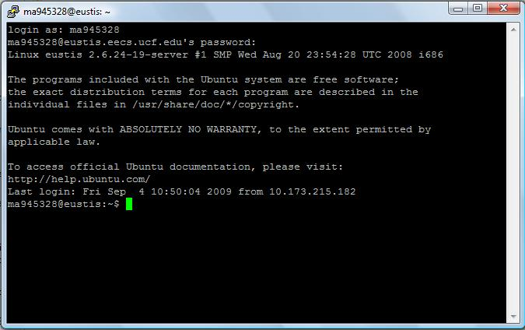

- The first thing that you want to type is “bash” this will allow for you to use such characters as backspace and the arrow keys. If you want to find out about any commands just type “man” followed by the command you want information for. If you are stuck in a long help file you can hit “Ctrl-z” to break out to the command line.
Using PSFTP (Transfer files between your computer and Eustis account)
- If you want to test or edit the files on your own computer and then upload them back to Eustis you could use PSFTP. This will allow you to upload/download files from your Eustis account. To do so open up PSTP by clicking START → PuTTY → PSFTP or download from http://the.earth.li/~sgtatham/putty/latest/x86/psftp.exe. There is another program with a better user interface which can be downloaded from http://winscp.net/eng/index.php, but the following steps are based on PSFTP.
- When PSFTP opens up you will need to connect it to the Eustis account in more of a Telnet fashion. When the window opens type “open Eustis.eecs.ucf.edu”. This will bring you to a user name and password prompt. You will use the same convention as used above in Step 3.
- When you are logged in type “ls” to see a list of the files (which should be empty initially). You should see a file list with file details and permissions.
- You can just type “help” to give you a list of FTP commands. I used the command “get” i.e. “get obj1.c” or if you want to download multiple files you could use “mget” i.e. ”mget obj1.c obj2.c”. The files you download will go to “c:\Documents and Settings\%Login Name%\”

References:
You can find similar tutorials on the following website
http://helpdesk.ucf.edu/tutorials/secure/index.html
Eustis machine is UNIX based. So you can refer to all the UNIX manuals and webpages mentioned above.
Some of the commonly used UNIX commands are tabulated below
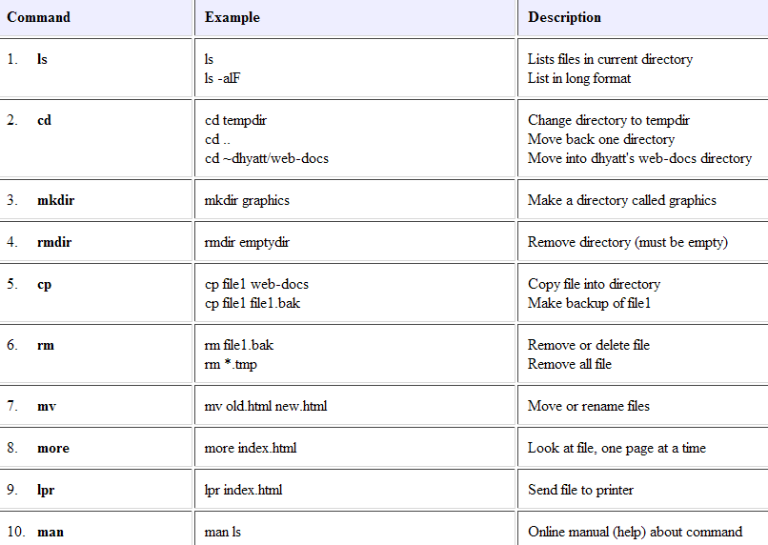

In order to open a file (.txt, .c, etc) you need to use an editor in the UNIX.
‘vi’ is the commonly used editor and to open a file you type in – vi <filename> in the command prompt.

There are a lot of tutorials available on the internet on basic vi commands.
Please refer to this webpage for most basic commands used frequently http://www.tjhsst.edu/~dhyatt/superap/vi.html

In order to compile your C programs in UNIX machine please read through the following page.
http://www-teaching.physics.ox.ac.uk/unix+prog/oxphy/c-comp.html

Most required commands

To compile: gcc –o <runfile> <filename.c>
To Run: ./<runfile>

