How to access Eustis Account, Transfer Files to the server and Some Common UNIX Commands

Common UNIX Commands
You can find several tutorials on UNIX online. Some of my favorites are:
http://www.ee.surrey.ac.uk/Teaching/Unix/
http://www2.ocean.washington.edu/unix.tutorial.html

Using PuTTY with UCF Eustis

- In order to connect to Eustis, you must be connected to an UCF network on campus, or you can establish a connection to the UCF VPN if you're off campus. Instructions to connect to UCF VPN are available at:
http://www.cst.ucf.edu/about/telecommunications/network-services/vpn/
- You also need an SSH client, for which you can download PuTTY from helpdesk website (or internet).
http://www.chiark.greenend.org.uk/~sgtatham/putty/
- Run PuTTY which will open up the following window.
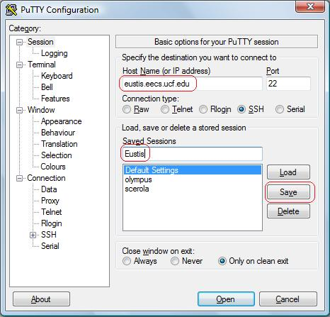
In the Host Name (or IP address) text box type the name of the UCF Eustis Server “eustis.eecs.ucf.edu”. Port 22 is selected by default and so is SSH. You cannot Telnet into Eustis anymore because of security reasons. Next in Saved Sessions text box type the name that you want for your SSH connection e.g., “Eustis”. Finally click Save. This will allow you to just click on Eustis the next time that you log in and click load. Finally click Open and you are ready to connect.
- When you click open in the PuTTY Configuration window the shell will open prompting you for a user name and password. Your User Name is your NID, and password by default is PYYMMDD. When the server asks for your password, while you type it in you won’t see anything (not “*” or dots). This is normal, just type in your password and hit enter. For Example if your birthday is July 4, 1980 then you would enter P800704 as your password. Once you have logged in you should get the following screen:
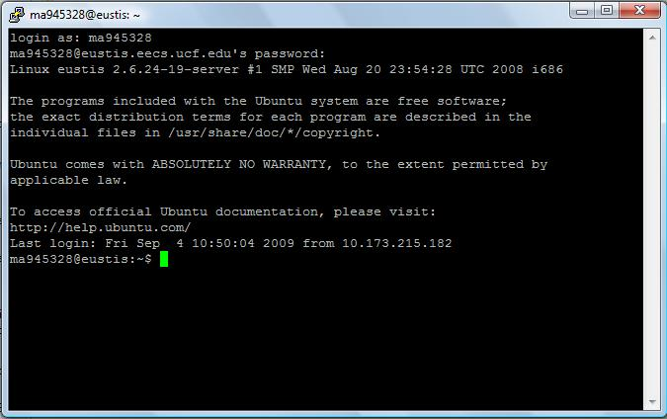

- The first thing that you want to type is “bash” this will allow for you to use such characters as backspace and the arrow keys. If you want to find out about any commands just type “man” followed by the command you want information for. If you are stuck in a long help file you can hit “Ctrl-z” to break out to the command line.

Using WinSCP (Transfer files between your computer and Eustis account)
- If you want to test or edit the files on your own computer and then upload them back to Eustis you could use WinSCP, which you can get from:
http://winscp.net/eng/download.php
- Once installed, run WinSCP which open up the following window:
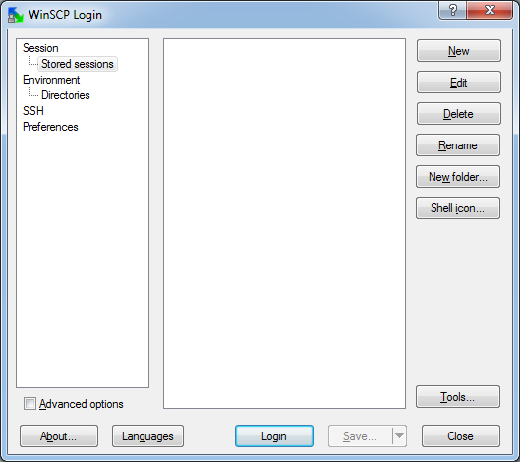
- Click on "New" to bring the next window:
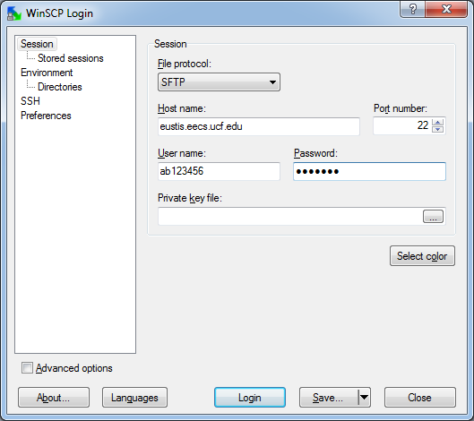
- For File protocol use SFTP or SCP. As for Host name, User name and password use the same ones you use to connect using PuTTY.
References:
You can find similar tutorials on the following website
http://helpdesk.ucf.edu/tutorials/secure/index.html
Eustis machine is UNIX based. So you can refer to all the UNIX manuals and webpages mentioned above.
Some of the commonly used UNIX commands are tabulated below
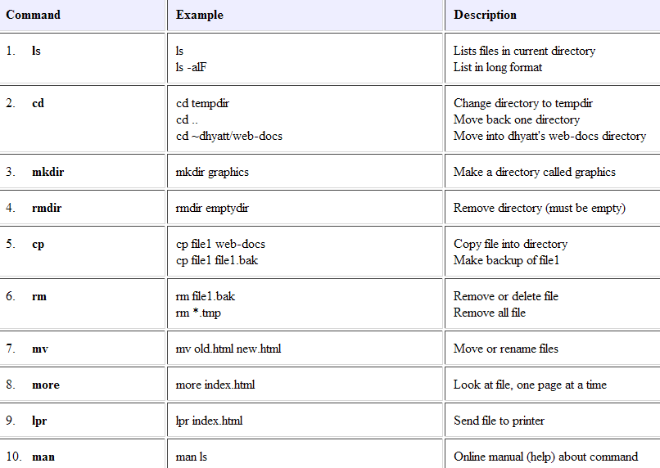

In order to open a file (.txt, .c, etc) you need to use an editor in the UNIX. Two common programs for this task are "nano" and "vi". You can type "nano <filename>" or "vi <filename>" in the command prompt to edit a file. There are a lot of tutorials available on the internet on how to use nano or vi.
Please refer to this webpage for most basic commands used frequently http://www.tjhsst.edu/~dhyatt/superap/vi.html

Compile your programs
In order to compile and run your C programs in UNIX machine do as follow:
To compile:
gcc –o <runfile> <sourcefile.c>
To Run:
./<runfile>
Note the period and forward slash before the name of the executable file.
Example: suppose your c program is named "vmhw1.c". To compile your source code you type in:
gcc -o test vmhw1.c
The "-o test" part of the command creates an executable file called "test". (The "-o" stands for
"output".)

If you left off the "-o test", the executable would be in a file called "a.out" by default.

Then to run it you have to type in:
./test

