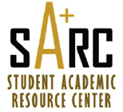

SI Sessions for

COP 3223 – 2
Day | Time | Room
Tuesday | 12:00 PM – 12:50 PM | HEC 103
Wednesday | 3:30 PM – 4:20 PM | BIO 209
Thursday | 3:00 PM – 3:50 PM | HEC 117
Friday | 12:00 PM – 12:50 PM | CB1 107

sites.google.com/site/ucfsarcsi
Instructor: Lobo
SI Leader: Ethan

