
School of Electrical Engineering and Computer Science
CNT 3004: Computer Network Concepts (Spring 2009)

Assignment 2
(Due date: Wednesday 02/11/09 in class)

Name: ______________________________________ PID: ____________________

- Television channels are 6 MHz wide. How many bits/sec can be sent if four-level digital signals are used? Assume a noiseless channel. (6 points)

- If a binary signal is sent over a 3 KHz channel whose signal-to-noise-ratio is 20 dB. What is the maximum achievable data rate? (6 points)

- A device is sending out data at the rate of 100 Mbps. How long does it take to send a file of 18 Mbits? How long does it take to send a file of 3,240 characters? (6 points)

- A periodic composite signal contains frequencies from 20 to 100 KHz, each with amplitude of 5 V. Draw the frequency spectrum. What is the bandwidth of the signal? (7 points)

- A non-periodic composite signal contains frequencies from 20 to 100 KHz. The peak amplitude is 5 V for the lowest and the highest signals and 20 V for the 40 KHz signal. Assuming that the amplitudes change gradually from the minimum to the maximum, draw the frequency spectrum. What is the bandwidth of the signal? (7 points)

- If we need to send 10 Mbps, what is the required bandwidth of a low-pass channel by using baseband transmission if we use one harmonic, three harmonics, five harmonics and nine harmonics? Now assume that we need to send 100 Mbps, what is the bandwidth required for the above cases? Complete the table. (10 points)
 | Required Bandwidth
Bit rate | Harmonics 1 | Harmonics 1,3 | Harmonics 1,3,5 | Harmonics 1,3,5,9

- A signal with 200mW power is transmitted by a bridge. It passes through several connectors and cables (as shown on the figure). If the losses at points A,B,C are 6dB each and the gain of the antenna is 19 dB, what is the power of the signal at point D? Tip: since dB and dBm are relative measures, they can be added or substracted when we are measuring several points. (7 points)
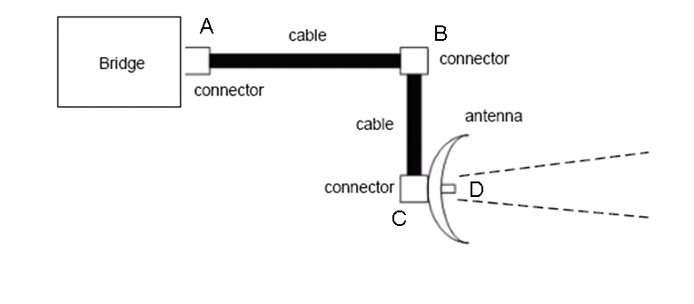

- A signal with 40mW power is transmitted. It passes through a coaxial cable. If the loss in the cable in decibels is 6dB, what is the power of the resulting signal? (7 points)

- We have a channel with a 10-MHz bandwidth. The SNR for this channel is 400. What are the appropriate bit rate and signal level? Tip: Use both Shannon formula and Nyquist formula. (6 points)

- What is the transmission time of a packet sent by a station if the length of the packets is 1 million bytes and the bandwidth of the channel is 200 Kbps? (6 points)

- What is the length of a bit in a channel with a propagation speed of 2x10⁸ m/s if the channel bandwidth is 10 Mbps? Tip: use the propagation time formula to get the bit length.

- How many bits can fit on a link with a 2 ms delay if the bandwidth of the link is 100 Mbps? (6 points)

- What is the total delay (latency) for a frame of size 5 million bits that is being sent on a link with 10 routers each having a queuing time of 2 us and processing time of 1 us. The length of the link is 2000 Km. The speed of the light inside the link is 2x10⁸ m/s. The link has a bandwidth of 5 Mbps. Which component of the total delay is dominant? Which one is negligible? (6 points)

- We have a channel with 200 KHz bandwidth. If we want to send data at 1 Mbps what is the minimum SNR_{dB}? What is SNR? (7 points)

- In the following figure, what is the bit rate of each signal? (7 points)

Important: I won’t receive any assignment after Wednesday 02/11/09, 11:59 pm. If for any reason you cannot come to my class that day, please send me an email with your assignment attached, and then on Friday 02/13/09, give me a hardcopy of the assignment.

