CGS 2545 – Database Concepts – Spring 2014

Homework #3 – 100 points – 10 points/problem

Due: Wednesday April 9, 2014 by 11:59 pm NO LATE ASSIGNMENTS ACCEPTED

Answer each of the following questions completely. Make sure that your answers are neatly written and very readable. Points will be deducted if your assignment is not presented in a neat format. Submit your assignment via WebCourses.

Use the database ERD shown below for all of the problems in this assignment.

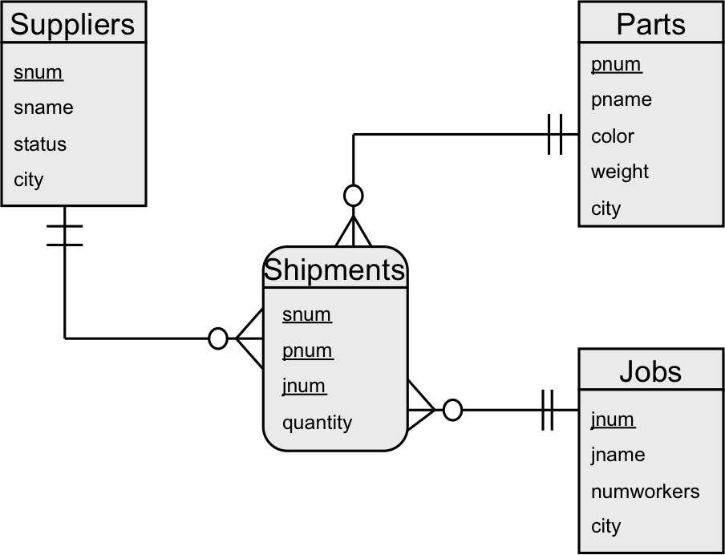

Where: in Suppliers: status is a numeric field, and all others are varchar fields.
in Parts: weight is a numeric field and all others are varchar fields.
in Jobs: numworkers is a numeric field and all others are varchar fields.
The city attribute has a common domain across Suppliers, Parts, and Jobs.

Do problems 1-5 using join operations.

- List the names of all the suppliers who supply part number P2 to any job.

- List the names of those cities in which there is both a job located that employs more than 200 workers and a part manufactured that weighs more than 200.

- List the names of those cities in which there is both a job and a supplier located.

- List the supplier names for those suppliers who supply at least one red part.

- List the job names for those jobs that receive at least one shipment from supplier number S1.

Do problems 6-10 using nested queries.

- List the names of those suppliers who ship a part that weighs more than 200 pounds.

- List the names of those suppliers who do not supply part number P2.

- List the names of all those suppliers who ship every green part to every job in Madrid.

- List the names of those suppliers who supply the same part to every job.

- List the names of those parts that are not supplied to any job.

