CGS2545, Spring 2001 Final Exam (4/24/01) Answer Key

S. Lang

Instructions: The test has three parts: Part I contains 17 multiple-choice questions where the answers must be selected from the list following the part, divided between Access questions and the Textbook’s questions. Part II contains questions about ER and EER models, ER to relation transformations, normal forms, and physical database design. Part III contains queries and SQL in MS Access. The reference sheets showing three tables and their relationships are provided for Part III. There are 100 total points.

Part I. Multiple-Choice questions (30 pts.).
Select the answers from the list following this part, and place the numerical label next to the answer into the blank space of the questions.
- An attribute that can be used to uniquely identify the individual instances (records) of an entity is _12_.
- The relationship between a weak entity type and its owner is _14_.
- The Totals feature of MS Access allows queries of summary data such as SUM, _1_ (name one more).
- The three-schema architecture for database development includes _19_, user view, and _24_ schemas.
- One feature that distinguishes forms from queries in MS Access is that forms support _2_.
- A physical database design technique which distributes the columns of a relation into separate files, repeating the primary key in each is called _20_.
- The field property _3_ of MS Access specifies that a data field must be in all capital letters.
- The advantages of using a database for managing information, compared to a traditional file processing system, include _21_ and _31_.
- _26_ is a related group of business processes that support the mission of an organization.
- The query type in MS Access that inserts additional records into an existing table is _6_.
- The asterisk notation ‘*’ used in a Access query is called a _8_.
- Two types of information in a composite usage map include _23_ and _28_.
- A table that is used to determine the locations of rows in a file satisfying some condition is _35_.
- A field of data that contains the address or location of a related field is _36_.
- The keyword _9_ is used in SQL statements to indicate multiple relations with related fields are used in constructing a query.
- _15_ is one or more fields which are used as an index to locate related records in an indexed file organization.
- The _29_ technology uses parallel processing and redundancy to improve file processing performance.

Answer List (1 – 36):
24. physical
25. total specialization rule
26. business function
27. supertype
28. data volume
29. RAID
30. functional dependency
31. minimal data redundancy
32. 2NF
33. transitive dependency
34. multivalued attributes removed
- index
36. pointer

Textbook’s answers (12 – 36)
- identifier
- generalization
- identifying relationship
- secondary key
- view integration
- normalization
- candidate key
- conceptual
- vertical partitioning
- improved data sharing
- enhanced ER modeling
- access frequencies

MS Access answers
(1 – 11)
- AVG
- layout of data
- input mask
- relationship
- subform
- append query
- update query
- wildcard
- join
  - Make-table query
11 data retrieval

Part II. ER models, relation transformations, normal forms, physical database design.

- (15 pts.) A bank operates several branch offices. Each branch is identified a branch ID, and has a head (person in charge) and a building address. The bank maintains records of customers and their accounts. Each customer record is identified by a unique ID, and contains the customer’s name, address, a home phone number and a work phone number. Each customer has one or more accounts with the bank. An account is identified by a unique account ID, and contains information about the cash balance, start date, type of the account, and one or more owners (customers) of the account. Customers go to a branch office to either deposit or withdraw money; such an activity is called a transaction and is identified by a unique transaction ID. Records of transactions are mailed to the customers in monthly statements showing the customer’s account ID, and the transaction’s amount, type, date, and the branch that performed the transaction. Use the following diagram as a basis to complete an entity-relationship (ER) modeling of the bank database. That is, add relationship(s), constraints, and attributes as appropriate, but do not add more entities to the diagram.

Customer

Branch

Account

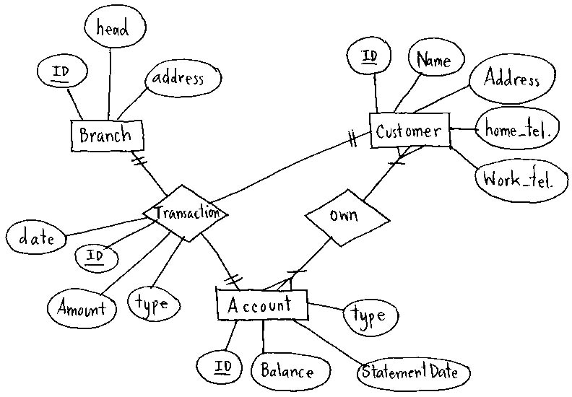

- (15 pts.) Transform each of the following ER (or EER) diagrams into a relational schema, showing the relation names, their attributes, the primary keys, and the foreign key to primary key links.
(a)

Billing-rate

Emp-ID
Name

Proj-ID

Employee
Project
Assigned-to
0

Address
Name
Start-date

Employee
Employee-ID | Name | Address

Assigned-to
Employee-ID | Proj-ID | Billing-Rate

Project
Proj-ID | Name | Start_date

(b)

Universal_ID
Name

Person

O

Student
Staff

GPA
Salary
Office

Person
Universal-ID | Name | type

Student
Student-ID | GPA

Staff
Staff-ID | salary | office

- (12 pts.) Suppose a single relation (table) is used to record the information about students, their major(s) and advisor(s), and the advisor’s rank (see below). We assume that each student may have one or more majors, but is assigned a single advisor for each of his (or her) declared majors. Each department (or major) has a unique department head; each advisor (professor) has a rank. Answer each of the following questions.

Student-ID Major Dept-head Advisor Rank

  - Show all the functional dependencies in this relation. (You only need to show the non-redundant dependencies.)

Student-ID Major Dept-head Advisor Rank

(b) Transform the relation into several relations in third normal form (3NF), showing the primary keys, functional dependencies, and the foreign key to primary key links.

Student-ID Major Advisor

Major Depart-Head

Advisor Rank

- (10 pts.) Suppose the following two relations (tables) have been considered for combining into a single relation. Answer each of the following questions.

Customer
Customer-ID Name Address

Order
Order-ID Product-ID Customer-ID Date Cost

- Show the combined single relation (table). Be sure to specify the primary key of the combined relation.

Order-ID | Product-ID | Customer-Id | Name | Address | Date | Cost

- Give at least one reason why the two relations are combined. Be as specific as possible.

Answer: To avoid joining, in case that most of query ask for customer and order information.

- What drawbacks does combining relations have? Briefly explain your answer.

Answer: Redundancy such as any anomalies, delete, update, insert (see detail in text book page 217)

Part III. MS Access (use the reference sheet for this question)
- (18 pts.) For each of the following questions, translate the query expressed in English into the corresponding SQL statement, and show the query results as requested.
  - Create a new table named “NewTable” which contains three fields “customerID”, “city”, and “country”, taken out of the lab2Customers table, in ascending order of the customerID values.
Show the SQL statement:

SELECT Customer-ID, City, Country INTO Newtable
FROM lab2Customers
ORDER BY customerID;

Show the first 2 rows of “NewTable”:

BLONP | Strasboung | France
CENTC | Mexico D.F | Mexico

  - Find the orderID and the number of productIDs for each orderID, from the lab2OrderDetails table, in descending order of the orderID field.
Show the SQL statement:

SELECT OrderID, Count(ProductID)
FROM Lab2Orderdetail
GROUPBY OrderID
ORDER BY OrderID DESCENDING ;

Show the first 2 rows of the query results:

10260 | 4
10259 | 2

  - Find the customerID, country, orderID, and orderDate from the lab2Customers and lab2Orders tables, in ascending order of the orderID field, where orderDate < 7/10/1996.
Show the SQL statement:

standard SQL:
SELECT CustomerID, Country, OrderID, OrderDate
FROM Lab2Customers, Lab2Orders
WHERE Lab2Customers.customerID = Lab2Orders, CustomerID AND Orderdate < 7/10/1996
ORDER BY OrderID

Access Style:
SELECT CustomerID, Country, OrderID, OrderDate
FROM Lab2Customers INNER JOIN Lab2Orders ON Lab2Customers.customerID = Lab2Orders.CustomerID
WHERE Orderdate < 7/10/1996
ORDER BY OrderID

Show the first 2 rows of the query results:

VINET | France | 10248 | 7/4/96
TOMSP | Germany | 10249 | 7/5/96

