CGS2545, Spring 2001 Test #2 (4/03/01)

===Answer Key ===
S. Lang
Instructions: The test has three parts: Part I contains 15 multiple-choice questions where the answers must be selected from the list following the part, divided between Access questions and the Textbook’s questions. Part II contains questions about EER models, ER to relation transformations, and normal forms. Part III contains one question about MS Access. A reference sheet of two tables is provided for Part III. There are 100 total points.

Part I. Multiple Choice questions (30 pts.).
Select the answers from the list following this part, and place the numerical label next to the answer into the blank space of the questions.

- __5__ defines entity types for more specialized entity types.
- An attribute of a supertype which determines the subtypes is __13__.
- __17__ is a completeness constraint.
- __16__ is a disjointness constraint.
- A generic entity type related to one or more subtypes is __19__.
- Inconsistency or error is __20__.
- Constraints between two attributes is __22__.
- A first normal form (1NF) and has no partial dependencies is __24__.
- A named two-dimensional table of data is __12__.
- An attribute or attributes on the left-hand side of a functional dependency is __14__.
- __10__ decomposes relations into smaller, well-structured relations.
- A reference to the primary key of the same relation is __26__.
- A form that is embedded within another form for showing the matched data fields in MS Access is __3__.
- Two or more attributes of a database that have different names but the same meaning are __8__.
- Merging relations of a database is __9__.

Answer List (1 – 27):
16. Overlap rule
17. Total specialization rule
18. Subtype
19. Supertype
20. Anomaly
21. Relationships
22. Functional dependency
23. 3NF
24. 2NF
25. Transitive dependency
26. Recursive foreign key
27. Multivalued attributes removed

Textbook’s answers (5 – 27)
- Specialization
- Generalization
- Homonyms
- Synonyms
- View integration
- Normalization
- Candidate key
- Relation
- Subtype discriminator
- Determinant
- Enhanced ER modeling

MS Access answers
(1 – 4)

- Table
- Relationship
- Subform
- Query

Part II. EER models, relation transformations, normal forms.

- (32 pts.) Transform each of the following EER diagrams into a relational schema (showing the relation names and their attributes, and foreign key to primary key links):
(a) (8 pts.)

Student_ID
Name
Phone_numbers

Student

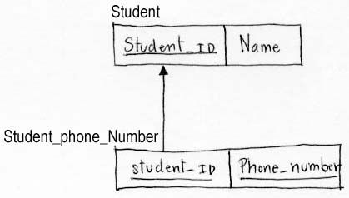

(b) (12 pts.)
Product
Order
0
Customer
0
Address

Product_ID
Unit_price

Customer_ID
Name

quantity

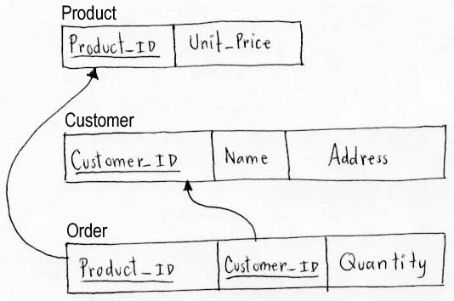

16 (c) (12 pts.)

Student_ID
Name

Student

d

Grad_student
Undergrad_student

Thesis_title
Dorm_fee

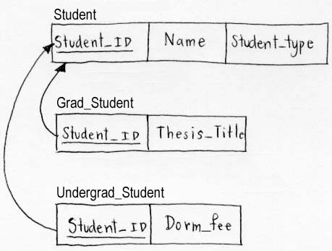

- (15 pts.) Convert the following ER diagram into an Enhanced ER (EER) diagram, demonstrating appropriate supertypes/subtypes in the EER model. We assume a student cannot be a faculty at the same time.
ID
Name
Name
Building
Office

Faculty
Work_for
Department

Student
Major_in

ID
Name
GPA

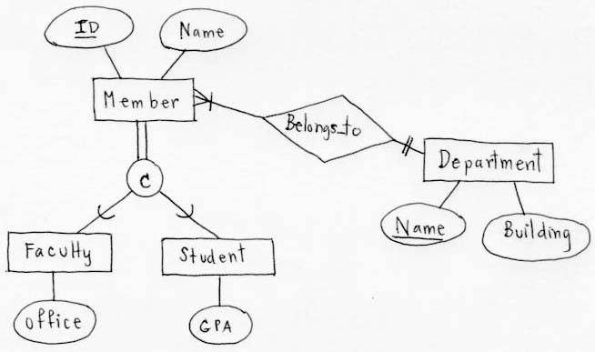

- (10 pts.) Decompose the following relation into appropriate relations in 3NF. In the decomposed relations, show the primary keys and functional dependencies, and show all foreign key to primary key links.

A B C D E

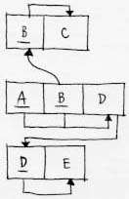

Part III. MS Access (use the reference sheet for this question)

- (13 pts.) Given the two tables lab2Customers and lab2Orders on the reference sheet, where customerID of the second table is a foreign key linked to the customerID field of the first table. Suppose an MS Access form is created containing the customerID and Country fields of the first table, and orderID and orderDate fields of the second table.
  - Show the record(s) in the subform area that correspond to each of the customers BLONP, CHOPS, and HANAR.

(Main form) (Sub form)

BLONP REANCE

CHOPS SWITZERLAND 10254 07/11/1996

HARNAR BRAZIL 10250 07/08/1996
10253 07/10/1990

  - How can you tell in Access that a subform has been created without opening the form file?
There will be a subform file.

