Solution Key #3

Part2

Item | Answer
2 | 17
3 | 22
4 | 19
5 | 15
6 | 27
7 | 14
8 | 6
9 | 7
10 | 1
11 | 16
12 | 25
13 | 30
14 | 12
15 | 23,29

Part3
- Consider a database of 3 tables: lab2Customers, lab2Orders, and lab2OrderDetails, and their relationship depicted on the reference sheets. Answer each of the following questions assuming this database and their records.
  - (15 pts.) Show the first 3 records retrieved from running the following query based on these 3 tables: Select fields [lab2Orders].[customerID] and [lab2OrderDetails].[quantity], where [orderDate] < 7/7/1996, sort the records in ascending order in [lab2Orders].[customerID]

  - (10 pts.) Show the first 3 records retrieved from running the following query based on these 3 tables: Select fields [lab2Customers].[customerID] and [lab2Orders].[orderID], sort the records in ascending order in [lab2Customers].[customerID], then in ascending order in [lab2Orders].[orderID].

  - (15 pts.) Suppose a query selects fields [lab2Orders].[orderID] and [lab2OrderDetails].[productID], and chooses “Group-By” and “Sort Ascending” under the column for the field [lab2Orders].[orderID] and chooses “count” under the column for the field [lab2OrderDetails].[productID]. Show the first 3 records when running this query.

Part3 : key 3 a

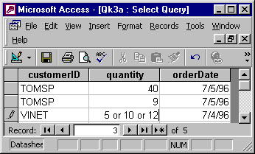
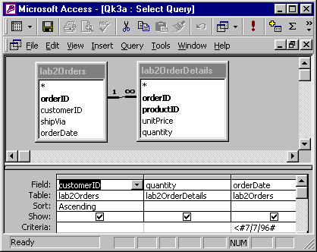
Part3 : key 3 b
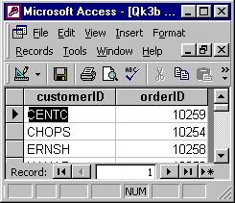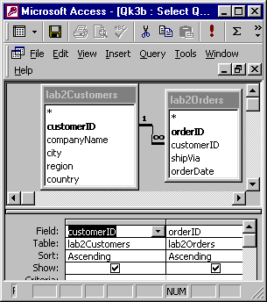
Part 3 : key 3 c
