Solution Key #2

Part2

Item | Answer
2 | 17
3 | 22
4 | 19
5 | 27
6 | 14
7 | 6
8 | 7
9 | 1
10 | 16
11 | 30
12 | 12
13 | 23,29
14 | 15
15 | 25

Part3

- Consider a database of 3 tables: lab2Customers, lab2Orders, and lab2OrderDetails, and their relationship depicted on the reference sheets. Answer each of the following questions assuming this database and their records.

  - (15 pts.) Suppose a query selects fields [lab2Orders].[orderID] and [lab2OrderDetails].[unitPrice], and chooses “Group-By” and “Sort Ascending” under the column for the field [lab2Orders].[orderID] and chooses “Max” under the column for the field [lab2OrderDetails].[unitPrice]. Show the first 3 records when running this query.

  - (15 pts.) Show the first 3 records retrieved from running the following query based on these 3 tables: Select fields [lab2Orders].[customerID] and [lab2OrderDetails].[quantity], where [orderDate] > 7/17/1996, sort the records in ascending order in [lab2Orders].[customerID]

  - (10 pts.) Show the first 3 records retrieved from running the following query based on these 3 tables: Select fields [lab2Customers].[customerID] and [lab2Orders].[orderID], sort the records in ascending order in [lab2Customers].[customerID], then in ascending order in [lab2Orders].[orderID].

Part3 : a
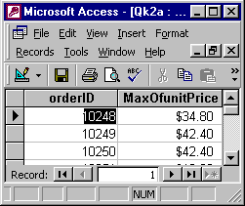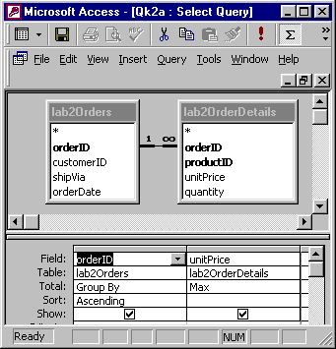
Part3 : b

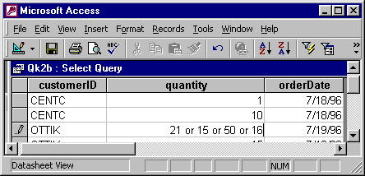
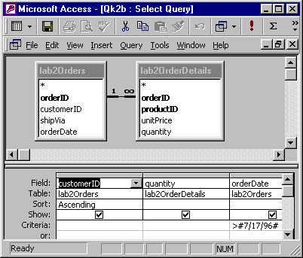
Part3 : c 