Solution for Assignment#4

6. Transforming an E-R diagram to relations:

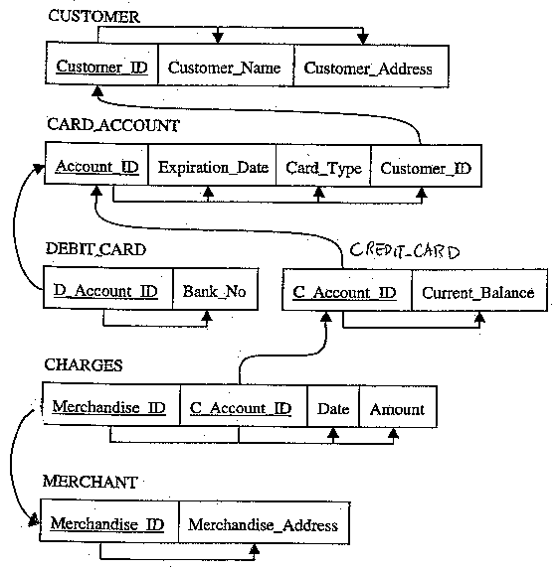

The criterion
Total: 22 points
3 points: show the link between Primary key and Foreign key
12 points: transform into table (2 points for each table)
6 points: show functional dependency
1 point: put in 3NF

7. Transforming Table 6-2 to relations:
- PART SUPPLIER

Part No | Description | Vendor Name | Address | Unit_Cost
1234 | Logic Chip | Fast Chips | Cupertino | 10.00
1234 | Logic Chip | Smart Chips | Phonenix | 8.00
5678 | Memory Chip | Fast Chips | Cupertino | 3.00
5678 | Memory Chip | Quality Chips | Austin | 2.00
5678 | Memory Chip | Smart Chips | Phonenix | 5.00

The criterion
Total: 3points

b. Part_No Description
Vendor_Name Address
Part_No, Vendor_Name Unit_Cost

The criterion
Total: 3 points
1 point per each

- Insert anomaly: we cannot insert a new vendor unless we also include a part number.
Delete anomaly: if we delete part information, we also loose information about a vendor who supplies that part.
Modification anomaly: if a vendor address changes, we have to modify all records (or rows) for that vendor.

The criterion
Total: 3 points
1 point per each definition

d.

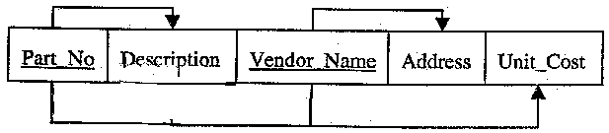

The criterion
Total: 4 points
1 point for each line

- 1NF

The criterion
Total: 2 points

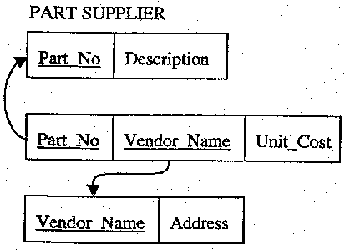

The criterion
Total: 3 points
1 point per each

