CGS2545, Spring 2001 Solution Key to Assignment #3 (40 pts.) March 10, 01

Answer to Question 1 (12 points) and Question 2 (13 points):

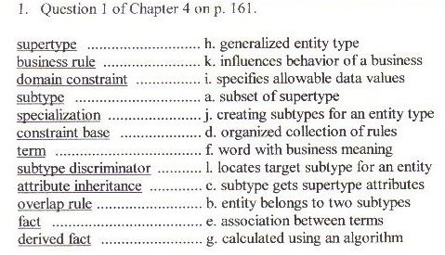

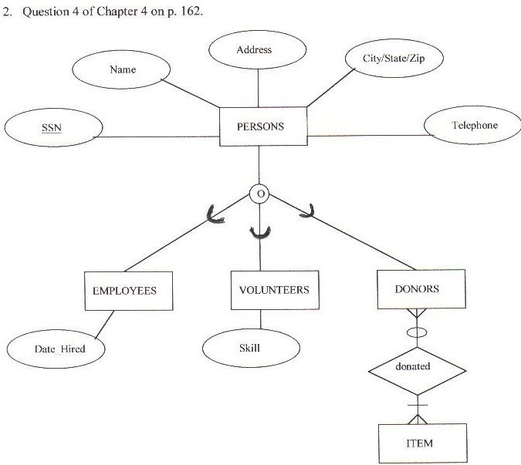

3. Results of Lab5’s Step 8 (10 points):

- CustomerID: VINET
lab5subfm1
ProductID | UnitPrice | Quantity
11 | $14.00 | 12
42 | $9.80 | 10
72 | $34.80 | 5
0 | $0.00 | 0
- CustomerID: TOMSP
lab5subfm1
ProductID | UnitPrice | Quantity
14 | $18.60 | 9
51 | $42.40 | 40
0 | $0.00 | 0
- CustomerID: HANAR
lab5subfm1
ProductID | UnitPrice | Quantity
41 | $7.70 | 10
51 | $42.40 | 35
65 | $16.80 | 15
0 | $0.00 | 0
- CustomerID: VICTE
lab5subfm1
ProductID | UnitPrice | Quantity
22 | $16.80 | 6
57 | $15.60 | 15
65 | $16.80 | 20
0 | $0.00 | 0
- CustomerID: SUPRD
lab5subfm1
ProductID | UnitPrice | Quantity
20 | $64.80 | 40
33 | $2.00 | 25
60 | $27.20 | 40
0 | $0.00 | 0
- CustomerID: HANAR
lab5subfm1
ProductID | UnitPrice | Quantity
0 | $0.00 | 0
- CustomerID: CHOPS
lab5subfm1
ProductID | UnitPrice | Quantity
24 | $3.60 | 15
55 | $19.20 | 21
74 | $8.00 | 21
0 | $0.00 | 0
- CustomerID: RICSU
lab5subfm1
ProductID | UnitPrice | Quantity
2 | $15.20 | 20
16 | $13.90 | 35
36 | $15.20 | 25
59 | $44.00 | 30
0 | $0.00 | 0
- CustomerID: WELLI
lab5subfm1
ProductID | UnitPrice | Quantity
53 | $26.20 | 15
77 | $10.40 | 12
0 | $0.00 | 0
- CustomerID: HILAA
lab5subfm1
ProductID | UnitPrice | Quantity
27 | $35.10 | 25
39 | $14.40 | 6
77 | $10.40 | 15
0 | $0.00 | 0

4. Results of Lab5’s Step 13. (5 points):

Record no. | 1 | 2 | 3 | 4 | 5
OrderID | 10248 | 10249 | 10250 | 10251 | 10252
CountOfproductID | 3 | 2 | 3 | 3 | 3
Lab5subfm2: productID | 11  42  72  0 | 14  51  0 | 41  51  65  0 | 22  57  65  0 | 20  33  60  0

