CGS2545, Spring 2001 Solution Key to Assignment #2 (40 pts.) Feb. 08, 01

Use Access database lab2DB.mdb to create the following 3 queries, after the lab2Shippers table has been added and a relationship to table lab2Orders set up (per Step 7 given above):
- (12 pts.) Select fields [lab2Customers].[customerID], [lab2Customers].[companyName], [lab2Orders].[orderID], and [lab2OrderDetails].[productID], sort the records in ascending order in [lab2Customers].[customerID], then in ascending order in [lab2Orders].[orderID], then in ascending order in [lab2OrderDetails].[productID].

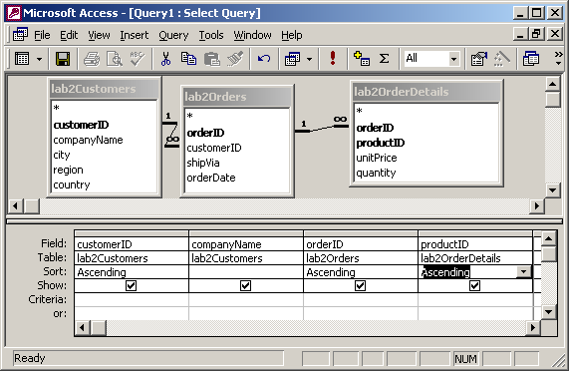
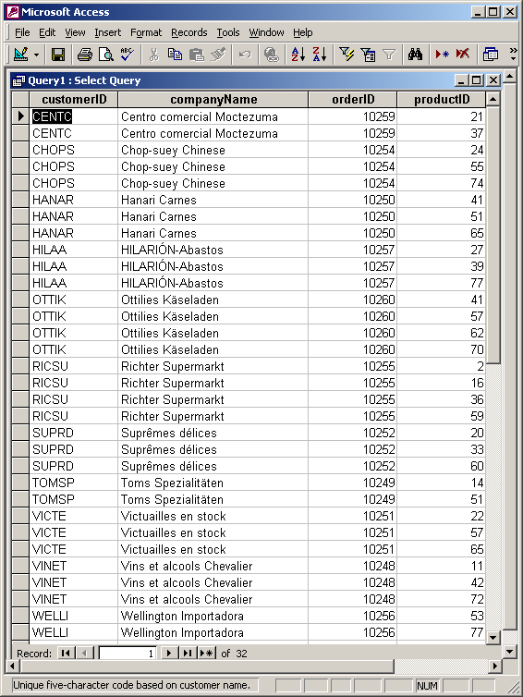

- (16 pts.) Select fields [lab2Orders].[customerID], [lab2Orders].[orderDate], and [lab2Shippers].[companyName] where [orderDate] < 7/15/1996 AND [companyName] = "Speedy Express", sort the records in ascending order in [lab2Orders].[customerID] then in ascending order in [lab2Orders].[orderDate].

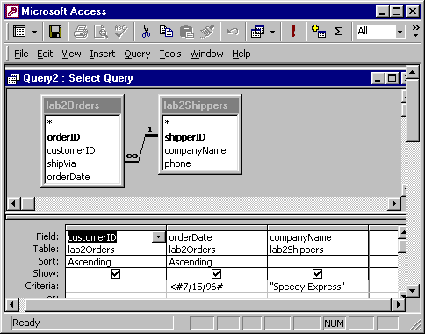

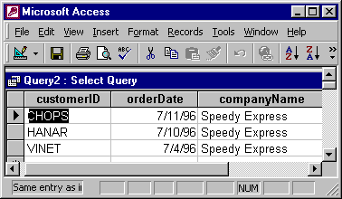

- (12 pts.) Select fields [lab2Orders].[customerID], [lab2Products].[productName], [lab2OrderDetails].[unitPrice], [lab2OrderDetails].[quantity], and [lab2Products].[UnitPrice], sort the records in ascending order in [lab2Orders].[customerID], then in ascending order in [lab2Products].[productName].
