Answer to Ques 2: Recall that in the Simple Neural Networks notes, we had been asked to find the backwards propagation steps for the pathway highlighted in the figure:
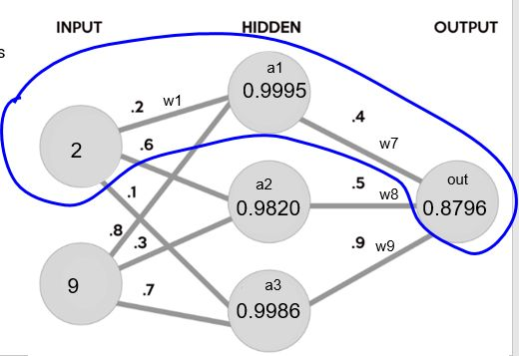

Isolating that pathway, gave us the following slide:
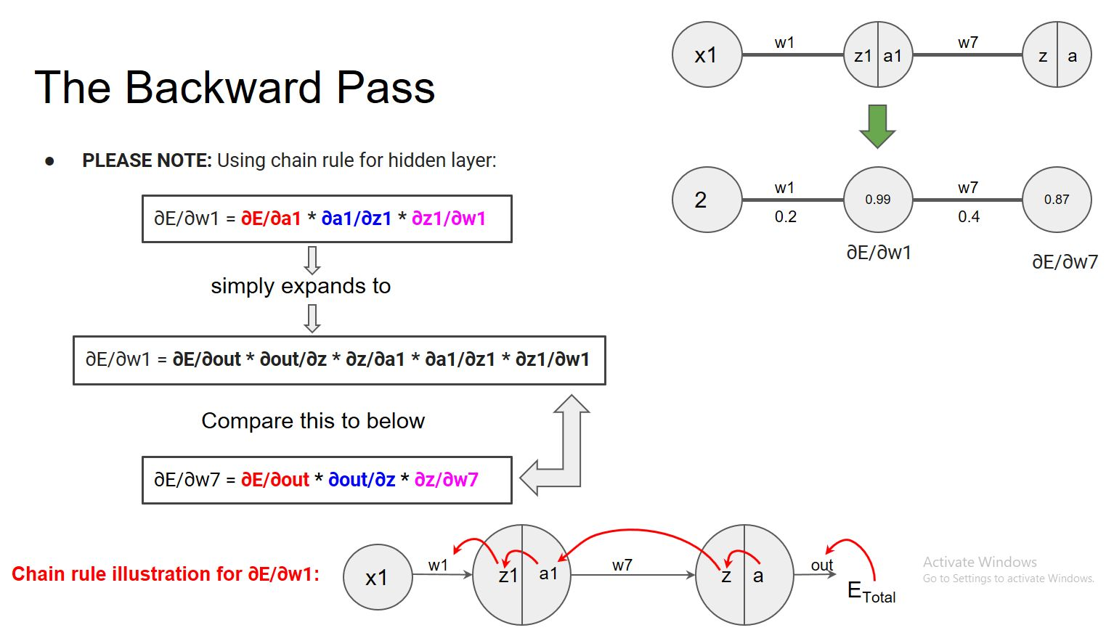

Then, focusing on
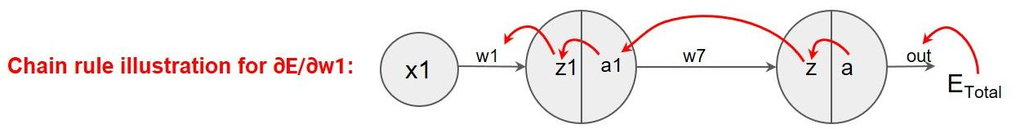

And paying attention to each of the red-arrows to obtain the dependencies,
we saw there that (note that “a” and “out” are the same quantities):

∂E/∂w1 = ∂E/∂out * ∂out/∂z * ∂z/∂a1 * ∂a1/∂z1 * ∂z1/∂w1

And, similarly, we saw that:

∂E/∂w7 = ∂E/∂out * ∂out/∂z * ∂z/∂w7

For our new problem in the practice test, we are being asked to do the newly highlighted pathway:

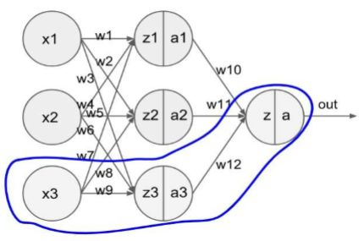

So, we will need to get:

∂E/∂w9

and, similarly, we need:

∂E/∂w12.

Using the same approach as before, we get:

∂E/∂w9 = ∂E/∂out * ∂out/∂z * ∂z/∂a3 * ∂a3/∂z3 * ∂z3/∂w9

and

∂E/∂w12 = ∂E/∂out * ∂out/∂z * ∂z/∂w12.

These last two equations are all that you need to write for the answer to this question.

