1.a.
Before we start, let us focus on the correct algorithm:
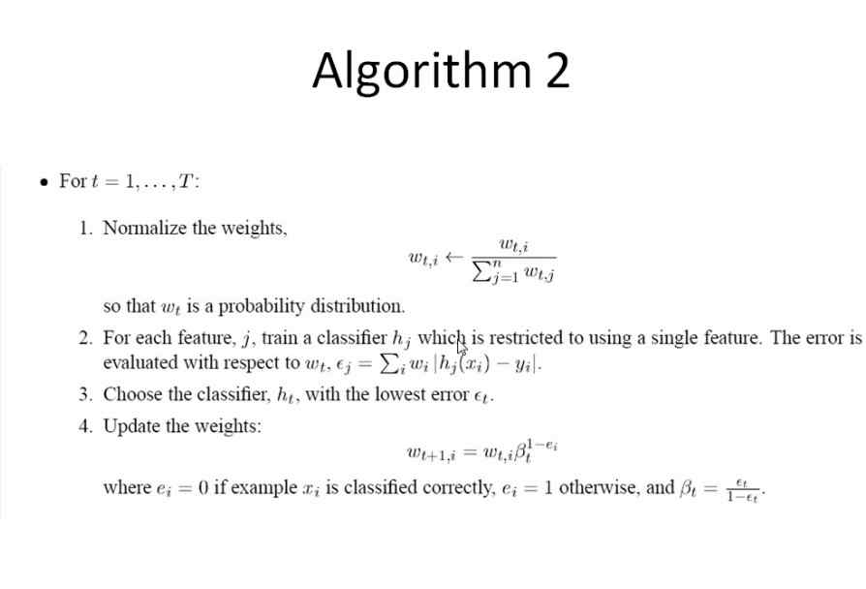

1.a. . Given
V X X
X V V
X V V
V X V

So, the step 1 in the AdaBoost algorithm said to make the weights 1/n (where n is the number of examples). We write:
W₁
1/4 V X X
1/4 X V V
1/4 X V V
1/4 V X V
So the correct answer for the first step is : the four numbers above.

1.b.
W₁
1/4 V X X
1/4 X V V
1/4 X V V
1/4 V X V
------------------------------------
¼ + ¼ ¼ + ¼ ¼ Error at
Time= 1
So correct answer at t = 1, is: ½ ½ ¼

1.c. The lowest error is ¼, so expert 3 is picked.

1.d. Beta from the boosting steps, is the quantity error/(1-error) so Beta is .25/.75 i.e. 1/3

Now, the Beta is 1/3 so, the update rule (step 4) in the algothm box says that the weights of the examples gotten wrong by expert (who was just chosen) , their weights stay the same.
If they were gotten right, their weights drop by a factor of Beta.

So. The weights are now:
¼ , ( 1/3 x ¼ ) , ( 1/3 x ¼ ) , ( 1/3 x ¼ )

i.e., ¼ 1/12 1/12 1/12

1.e. This step takes us back to step 1 of the boosting box.

We first compute the sum of all, answer is ¼ + 1/12 + 1/12 + 1/12 is ½.

Then we divide every number by this sum ½,

So, our normalized values become: ½ 1/6 1/6 1/6 (which adds up to 1)

So we keep track of this at :
W₂ W₁
1/2 1/4 1/4 V X X
1/6 1/12 1/4 X V V
1/6 1/12 1/4 X V V
1/6 1/12 1/4 V X V

1.f
W₂ W₁
1/2 1/4 1/4 V X X
1/6 1/12 1/4 X V V
1/6 1/12 1/4 X V V
1/6 1/12 1/4 V X V
------------------------------------------------------
Was Error at T= 1 ½ ½ ¼
Now, error at T=2, 1/6 +1/6 ½ + 1/6 1/2

1.g. Expert 1 is picked.

